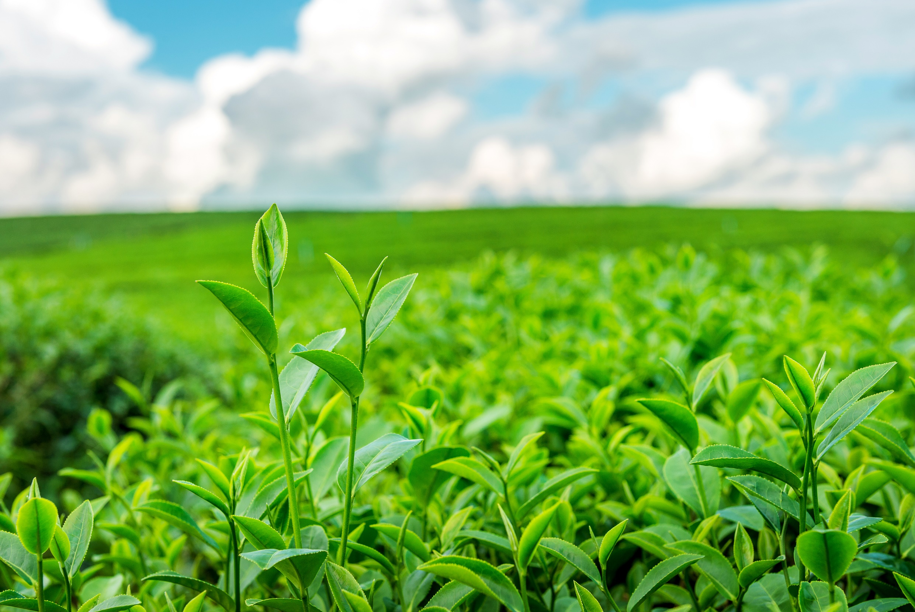

Ajeevika

Admin Manual

**Admin User Manual**

**By Kamtech Associates**

**Table of Contents**

**Introduction** 4

**Section 1: Getting Started** 5

1.1. Opening the Admin Panel 5

1.2. Login/Logout and Forget Password 7

1.3. Admin Dashboard 9

1.3.1. Overall KPIs 10

1.3.2. Navigation Pane 16

**Section 2: Stakeholder Management** 17

2.1. Admin User Management 17

2.1.1. Create New Admin User 18

2.1.2. Edit Admin User details 19

2.1.3. Block/Unblock existing admin user 20

2.2. User Management 21

2.2.1. Exporting User Data 22

2.3. Product Management 26

2.3.1. Export Product Data 26

2.3.2. View/Edit/ Disable Product 34

2.3.3. Document Management 37

**Section 3: Catalogue Management** 38

3.1. Category Management 38

3.1.1. Add Category & Sub-Category 39

3.1.2. View/Edit/Disable Category 42

3.2. Product Type Management 45

3.3. Template Management 47

3.3.1. Add New Template 49

3.3.2. Edit a Template 50

**Section 4: Marketing & Promotion Management** 51

4.1. Banner Management 51

4.1.1. Add New Banner 51

3.3.3. Edit Banner 53

**4.2.** Popup Management 55

4.2.1. Add New Pop-up 56

4.3.2. View/Edit/Enable/Disable/Delete pop-ups 57

4.4. Promo & Marketing Management 59

4.4.1. Sending Push Notification 59

**Section 5: Order Management** 61

5.1 Order Management 61

5.2 Interest Management 63

**5.3** IndividualOrder Management 65

**Section 6: Other Features** 67

6.1 Sarvottam Management 67

6.2 Sadhan Management 69

6.3 Suvidha Management 71

**Section 7: Support & Grievance Addressal** 75

7.1 FAQ Management 75

7.2 Grievance Management 77

# **Introduction**

1. **About this application**

“Ajeevika Admin Manual” is a is a web platform for the admin (operators), to manage the entire process in Ajeevika Web portal & Mobile App

**Purpose of the document:**

This document is aimed at serving as a guide for Admins on the use of the Web Platform. The manual covers various modules which will help manage the digital profiles of Users, SHG Individual and Enterprise and their products displayed on the web platform and mobile app.

1. **For further information**

To know more about this application, or for suggestions / feedback, please contact:

**Aajeevika Support Team, UNDP India** (supportaajeevika@undp.org)

1. **Disclaimer**

This document is prepared as an artifact to facilitate training on the digital product developed under " Technical support for the upgradation, enhancement of Uttarakhand Ajeevika and creation of Marketplace module".

Best effort has been put to ensure that the content of this document is in sync with the actual product, however, since software products can undergo multiple changes, hence it is not guaranteed that this document aligns with the latest product version. Certain administrative features can result in modification or deletion of the data permanently from the repository; hence the user / administrator of this product must exercise utmost care with required knowledge to execute such actions. The creator or owner of this document does not accept any liability of any untoward repercussions arising out of the product usage or information mentioned in this document. All the rights of this document lie with the owner of the above-mentioned digital product.

# **Section 1: Getting Started**

## Opening the Admin Panel

**On Desktop**

1. Open any installed browser on your desktop
2. Go to <https://api.undp-uttarakhand.tk/admin/login>
3. Enter the login credentials assigned to you and press “Login” button

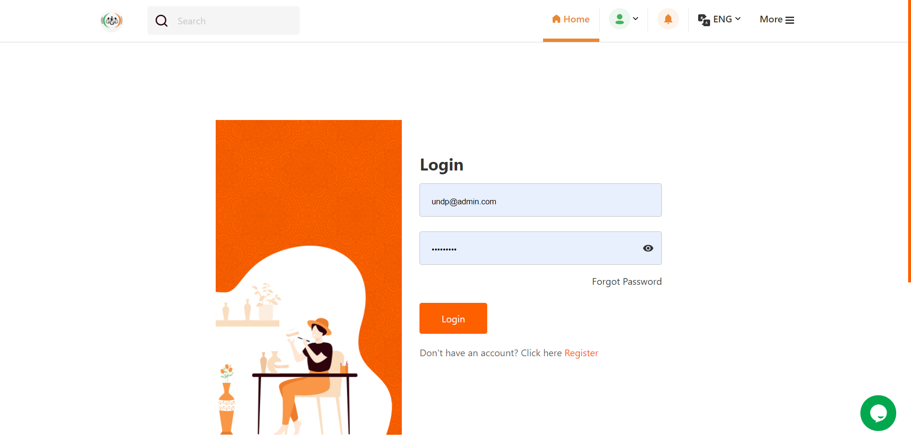

1. You will enter the Admin Panel and dashboard will appear.

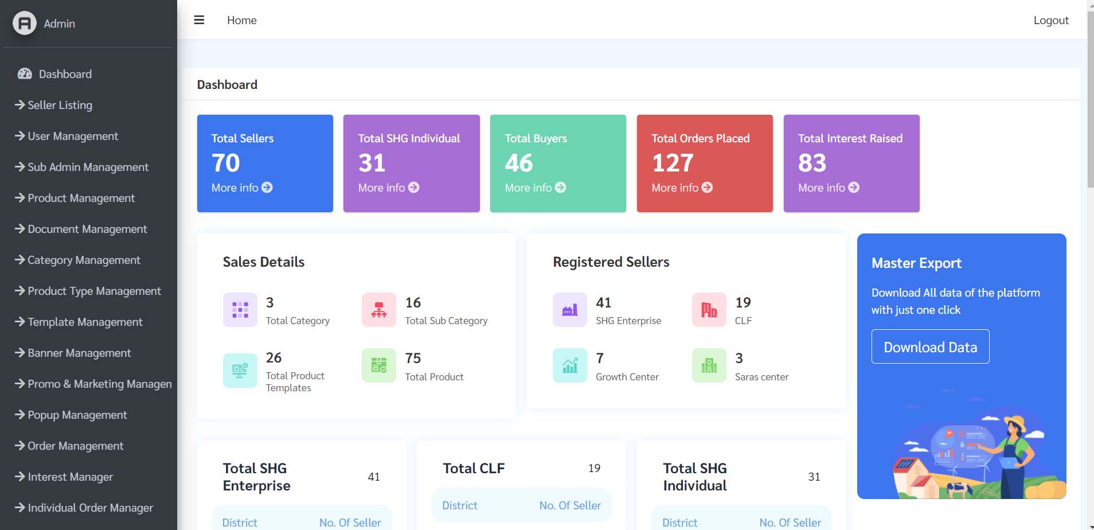

**On Smartphone**

1. Open any installed browser app on your smartphone
2. Go to <https://api.undp-uttarakhand.tk/admin/login>
3. Enter the login credentials assigned to you and press “Login” button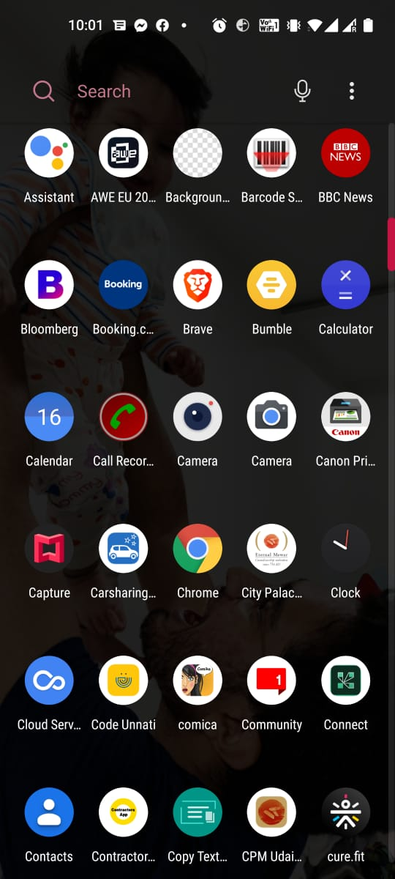

## Login/Logout and Forget Password

* Admin will Login with their given email and Password in login panel
* If Users/Admin forgets his/her password, then they need to click on “forget password” button.



Login Panel

Forget Password Button

* Admin needs to enter his/her Registered mobile no. and will receive OTP via SMS.
* After entering OTP, he/she will be redirected to change password page where, admin needs to enter new password.

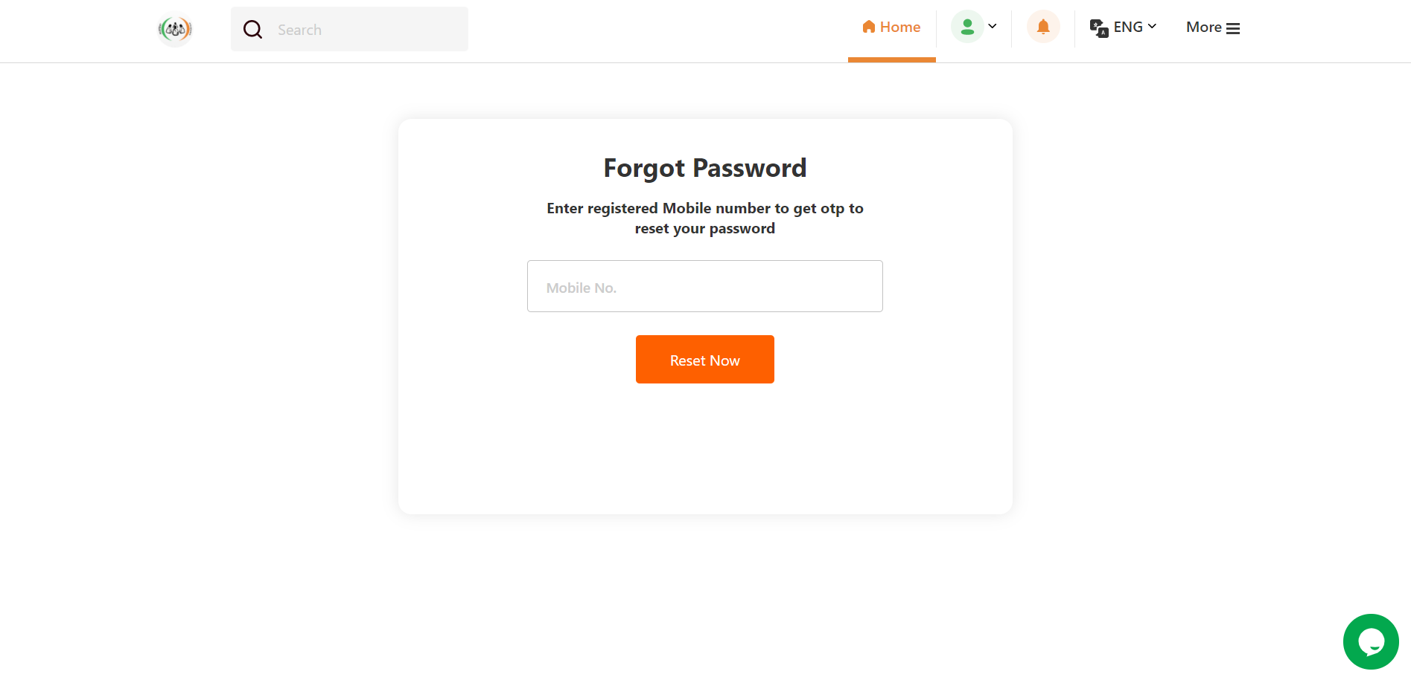

* To logout from admin panel, admin needs to click on logout button on top right corner of screen.



## Admin Dashboard

This is the overall dashboard, and the first screen that appears when the admin logs in. Here you will find the overall KPIs on the top, each KPI is clickable and leads to its respective table/report. The master control panel is placed on the left side, which contains links to various modules.

Navigation Pane



Overall KPIs

District wise data

### Overall KPIs

**Total Sellers-** Total No. of sellers listed on the portal will be shown here and by clicking “More info” button, it will redirect you to Seller Listing page.

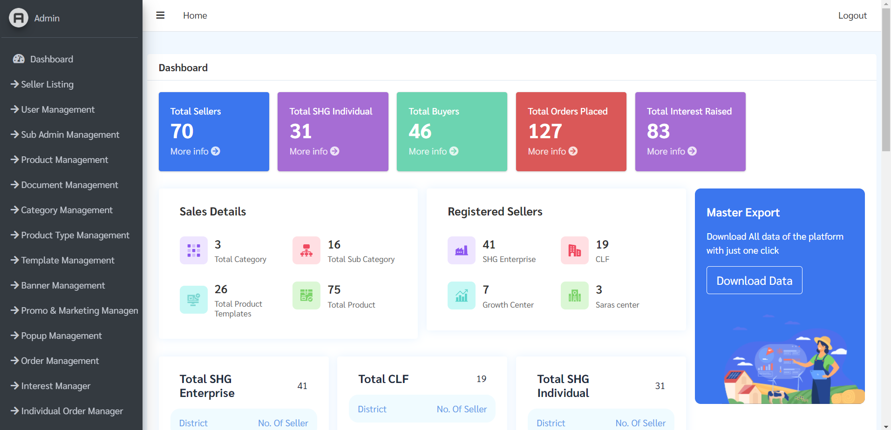

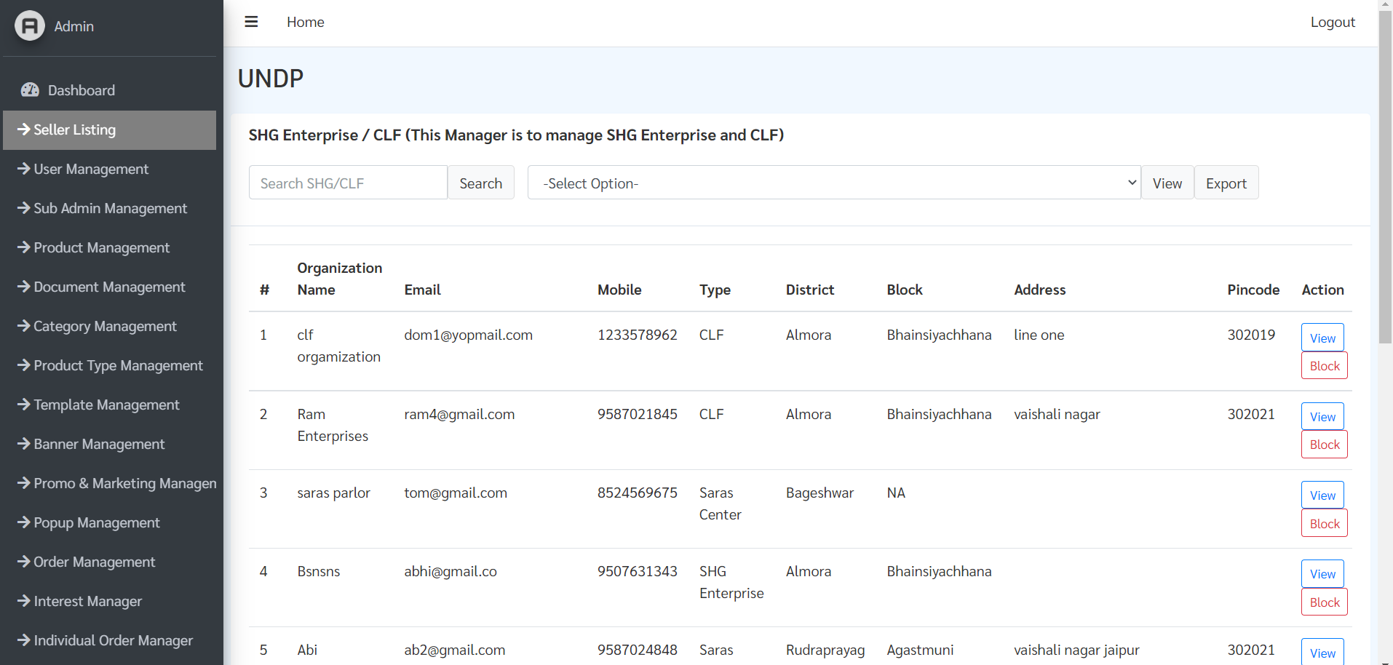

Seller Listing page

**SHG Individual-** Total No. of SHG Individual listed in the platform will be shown here, and by clicking “More info” button, it will redirect you to Category Management page.



SHG Individual Management Page

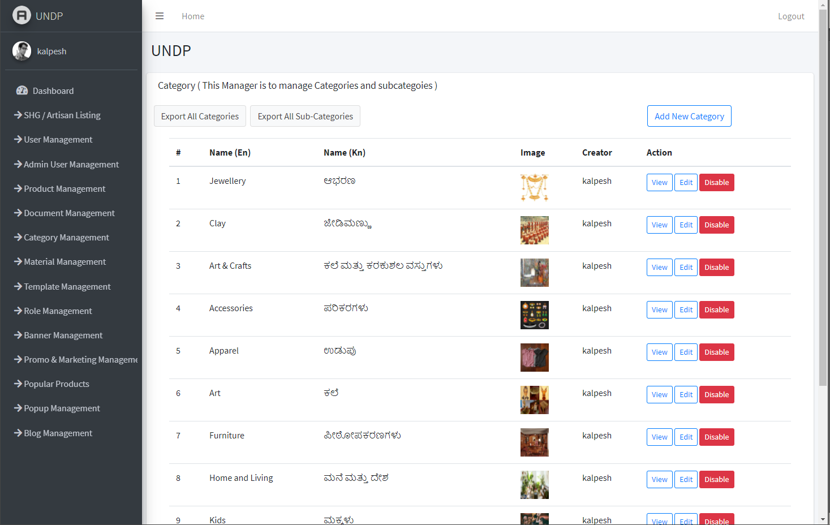

**Total Product –** Total products listed on the platform will be shown here and clicking on “More info” button willredirect you to product management page.



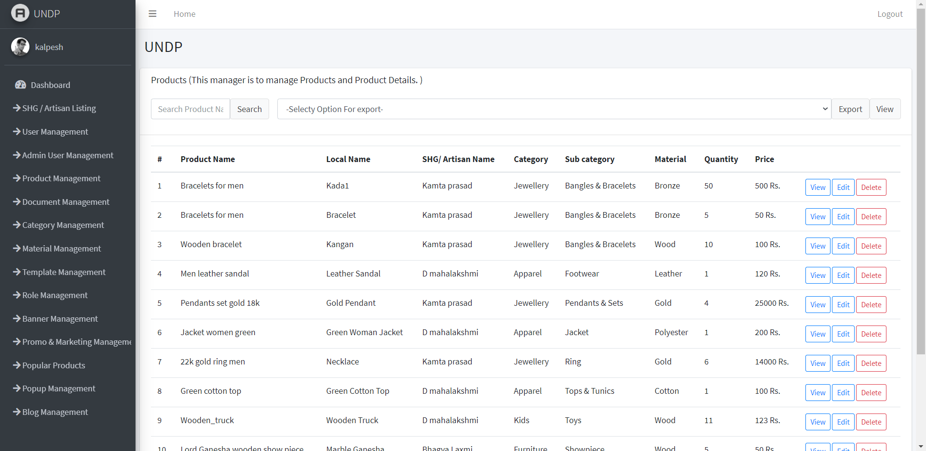

Buyer Management Page

**Total Orders –** Total orders placed on the platform will be shown here and clicking on ‘More info’ button willredirect you to product listing page.



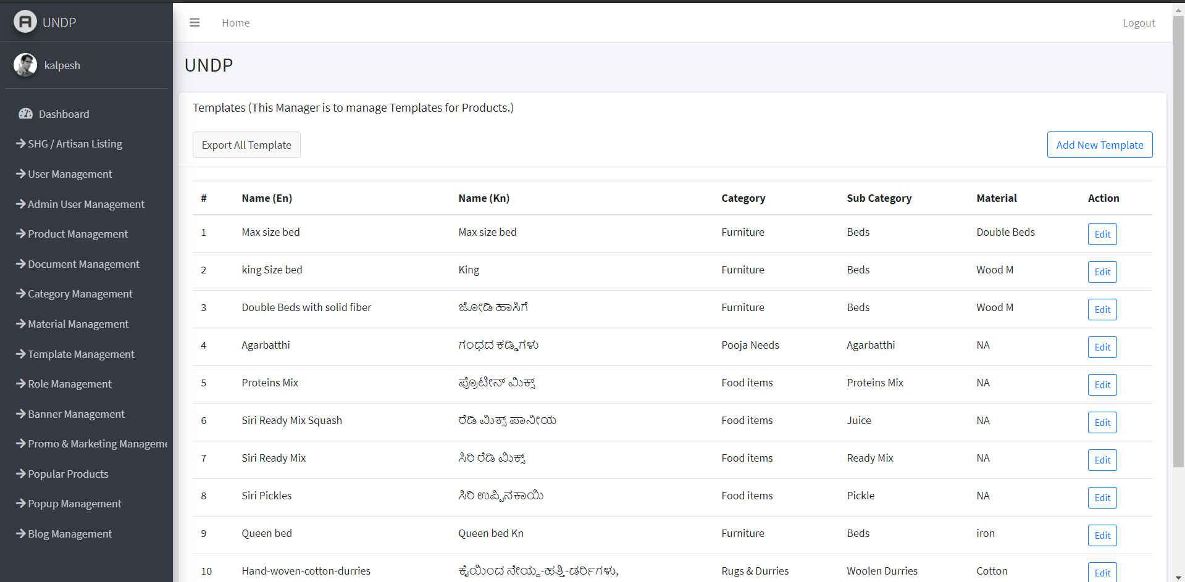

Template Management Page

**Interest Received –** Total materials listed on the platform will be shown here and clicking on “More info” button willredirect you to material listing page.



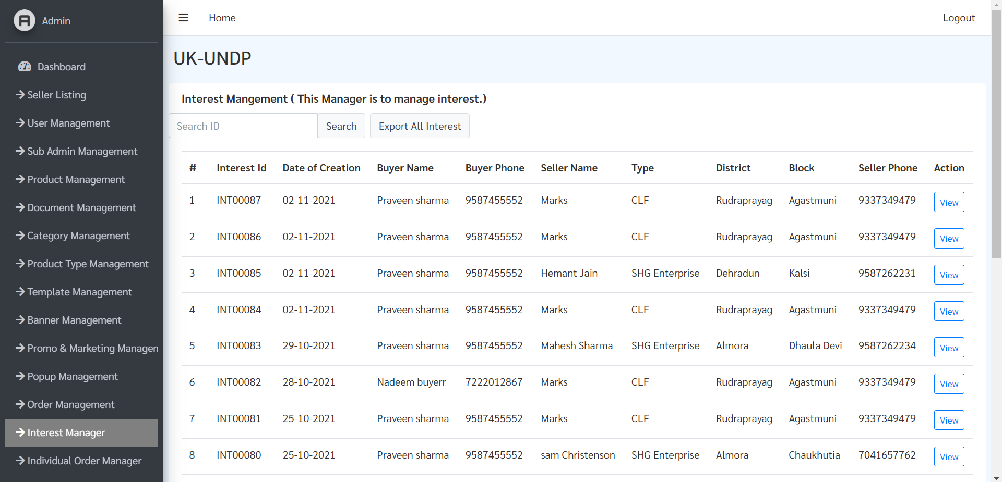

Interest Management Page

**Export (Master Report) –** By clicking on the “Export Master Report” button in the highlighted tab, complete data of the platform including Users, SHG Individuals, Artisans will be exported as an excel file.



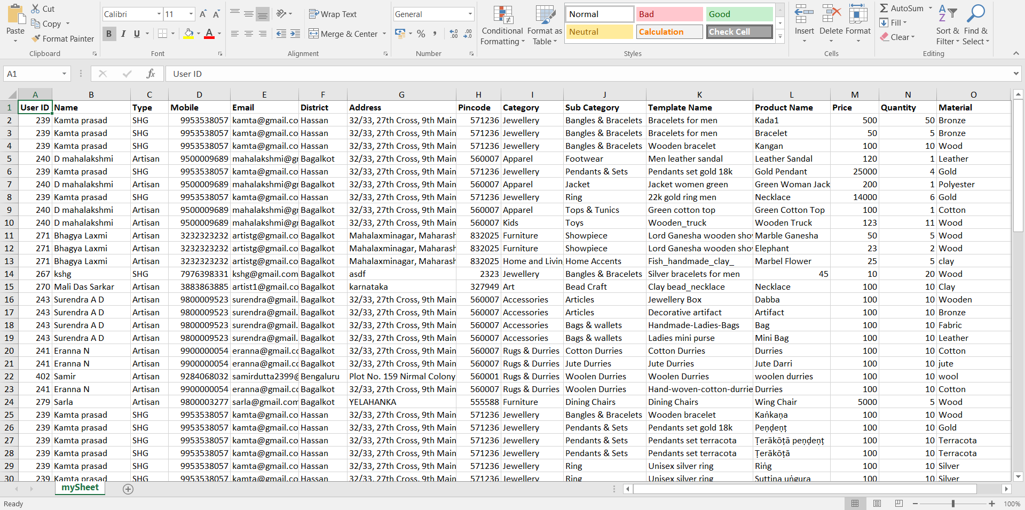

All data of platform

### Navigation Pane

Admins can navigate to different modules with Navigation pane, available to the leftof screen.

Navigation pane will have different options for both state and district admins depending on the role-based permissions granted by State Admin.

**Modules Available:**

* Dashboard
* Seller Listing
* User Management
* Sub Admin Management
* Product Management
* Document Management
* Category Management
* Product Type Management
* Template Managemnt
* Banner Management
* Promo & Marketing Management
* Popup Management
* Order Management
* Interest Manager
* Individual Order Manager
* Individual User Manager
* Collection Center
* Individual Category
* Certificate Management
* Grievance Management
* Survey Management
* Individual Interest Type Management
* Sarvottams Management
* Sadhan Management
* Suvidha Management
* FAQ Management
* Sadhan Category Management

Different Managers to different admins according to permission granted

# **Section 2: Stakeholder Management**

## Admin User Management

From this module, the Super Admin can create sub Admins and allocate them role-based permissions. The original admin account, i.e. the Super Admin account must not be deleted or mishandled.

In this module, admin can:

* View all registered admins in the platform
* Create new admins
* Edit any registered admin
* Block existing admin

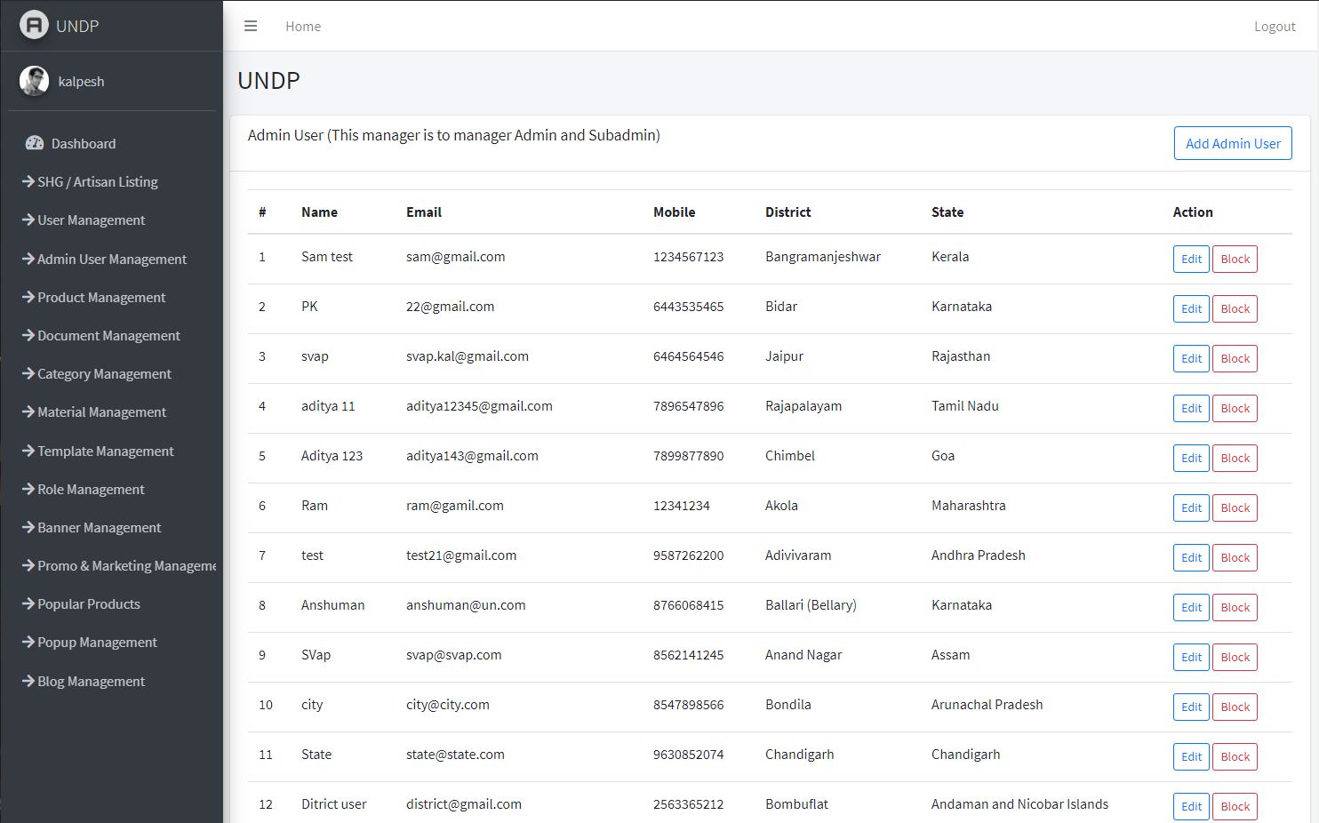

View all registered admins from the list

### Create New Admin User

Step 1: To add another admin in the platform, click on “Add Admin User button” (highlited above), then fill in the following admin details:

* Name
* Email Id
* Phone No.
* Role- Select role i.e DTE, State, BMM
* State and District Name
* Enter Password and Confirm Password
* Check mark the required permissions (modules) to be made available to the State/District admin user being created.

Each module corresponds to a specific management feature. These modules are to be allocated as per the roles and responsibilities defined for state and district admins. Each of these modules are explained individually in the manual.

**Permissions available for State Admin:** All modules

**Permissions available for District Admin:** SHG / Artisan Listing, Product Management, Document Management

Step 2: After filling in all the details click on “Add Admin User” button highlited below.

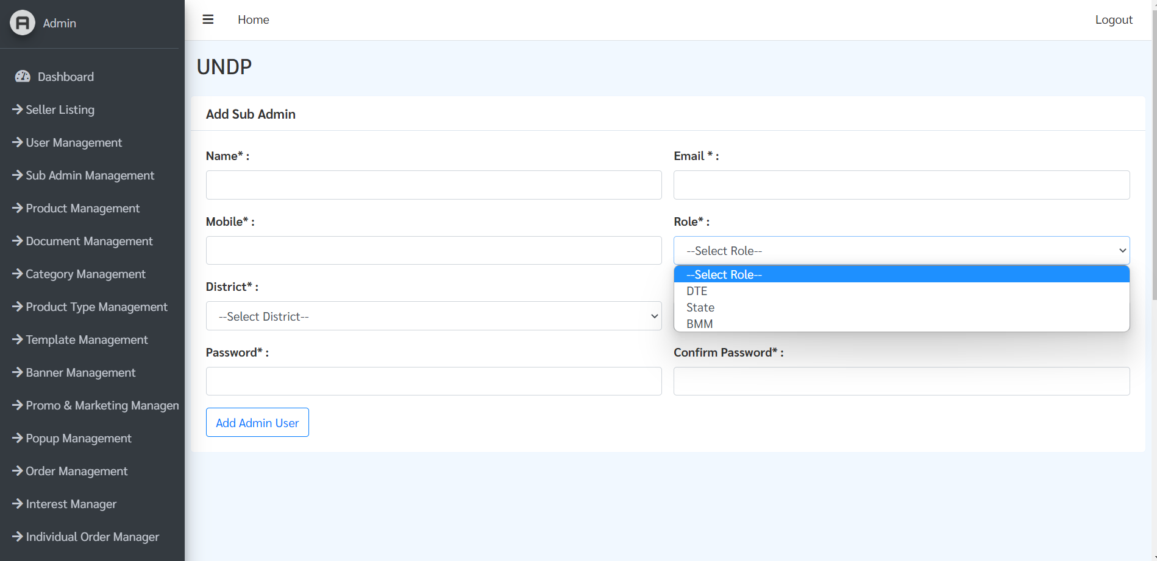

### Edit Admin User details

Step 1: Click on Edit button (highlighted below) for the admin whose details you want to change.

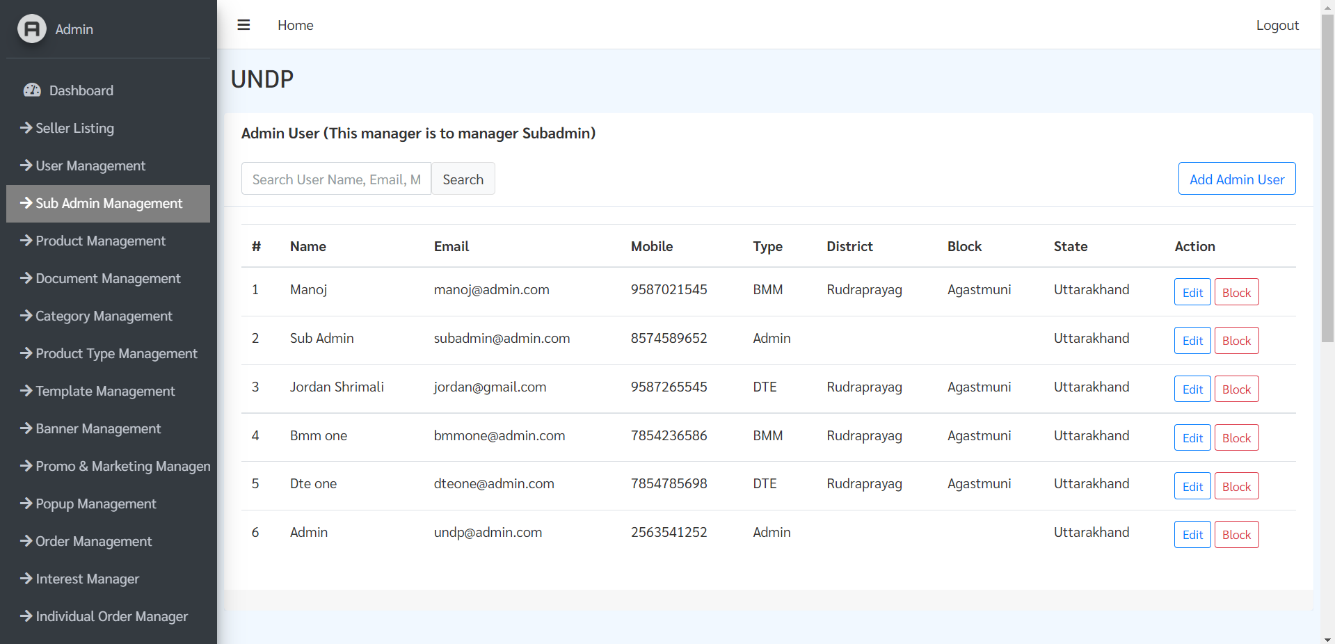

Step 2: Then the selected admin’s details will be displayed, here state admin can edit other admin details. After making necessary changes click on “Save Changes” button highlighted below.

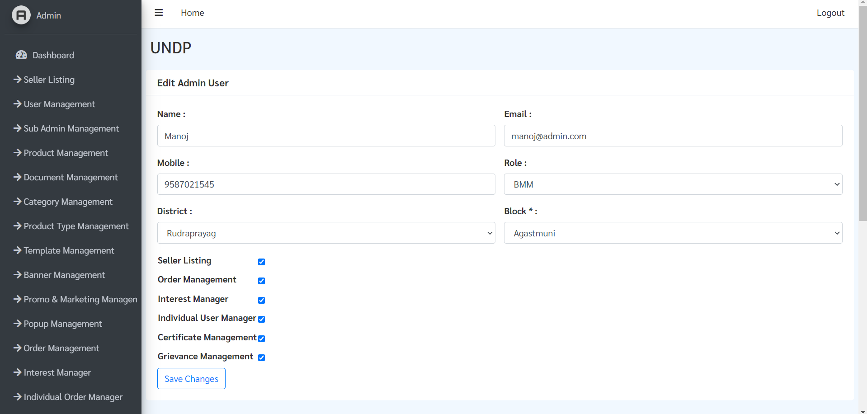

### Block/Unblock existing admin user

Step 1: To block/unblock an admin user, click on “Block button” highlighted below.

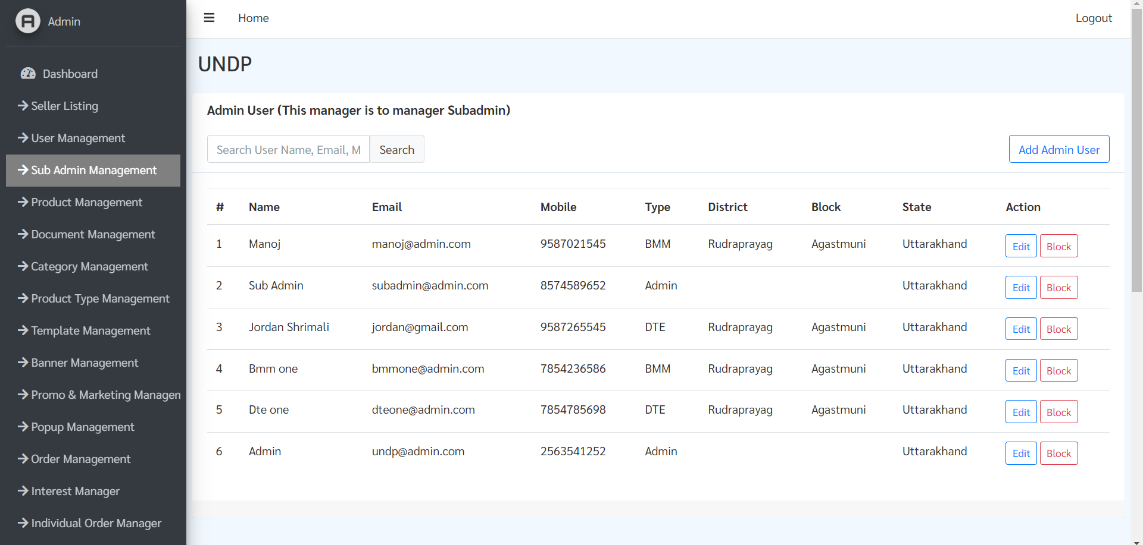

Step 2: After clicking on Block button, a pop up will appear from top to confirm your action, click on OK to block.

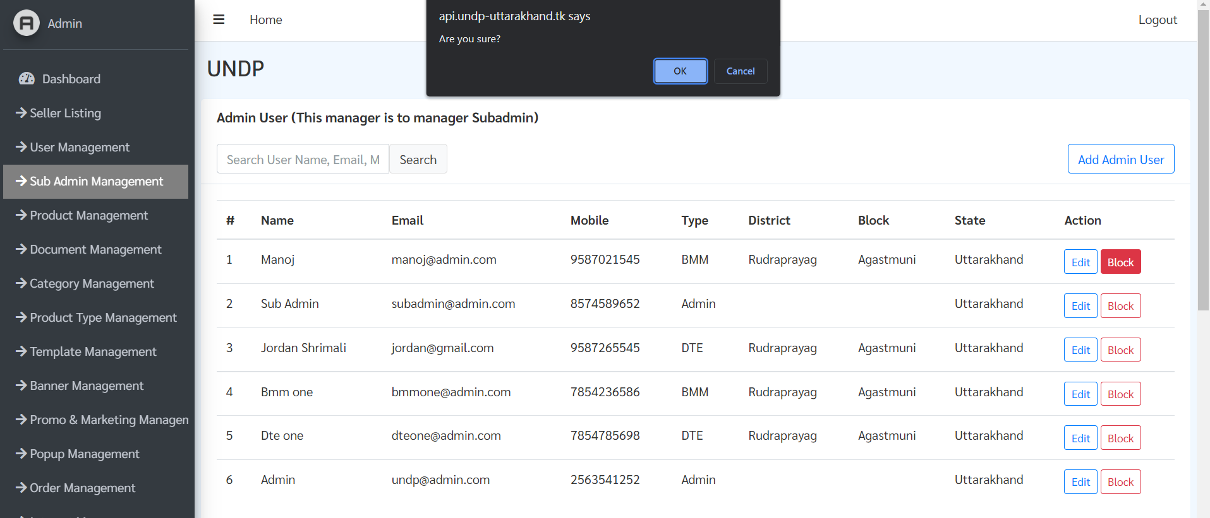

Step 3: To Unblock an user, follow the same procedure as above and click on Unblock button instead.

## User Management

Users are customers/consumers who have registered on the platform to view products.

* Search registered user
* Block/Unblock user
* Export user data

**Search User:** To search for any users registered in the platform, type his/her name in the search box then click search

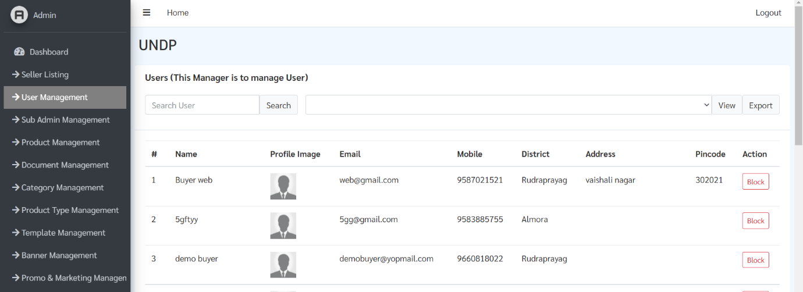

Search Bar

**Block/Unblock User:** To block any users, click on “Block” button next to his/her name,

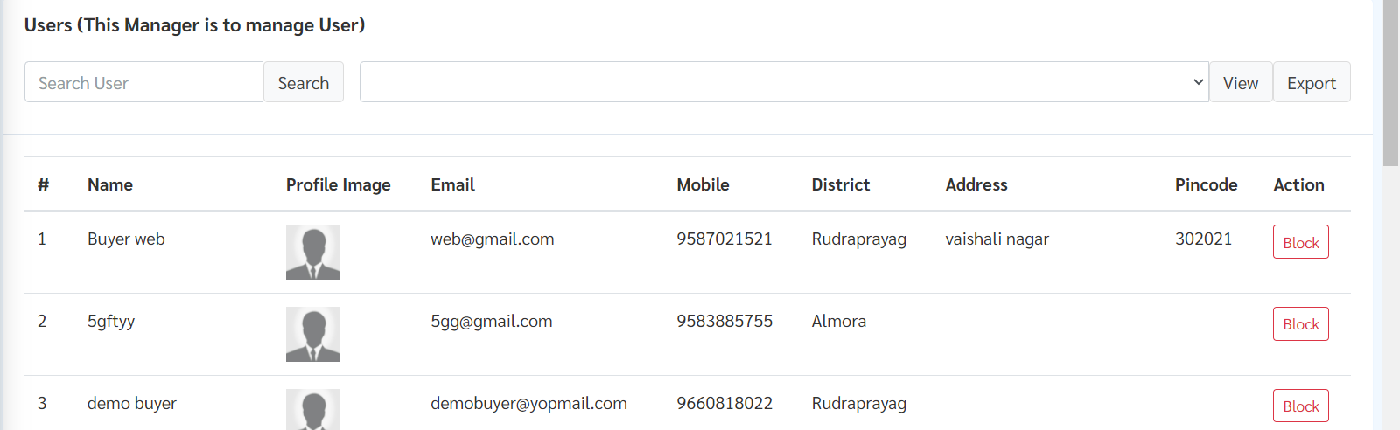

To unblock a blocked user click on Unblock button next to his/her name.

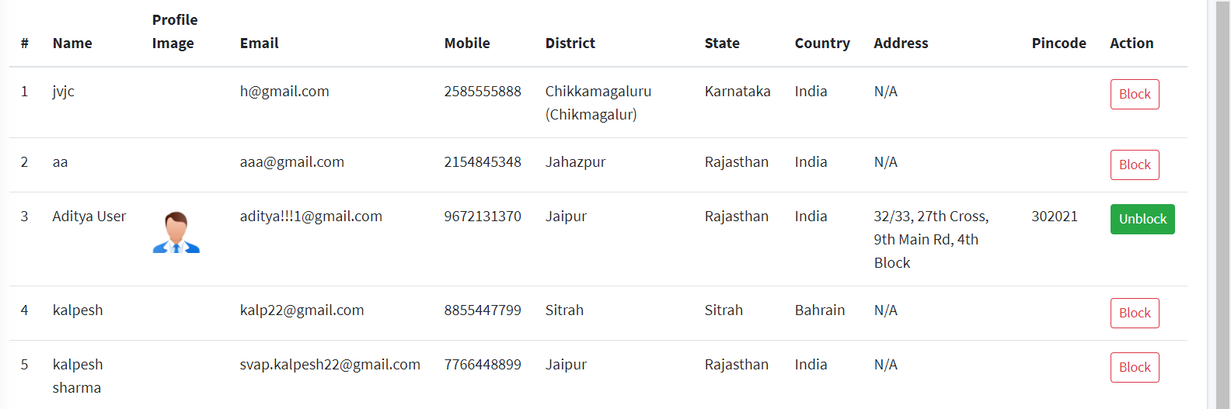

### Exporting User Data

**All user data export/view**

This will export the list of all registered users in the platform.

Step 1: To export list of all registered users in platform, select “All” from dropdown menu.

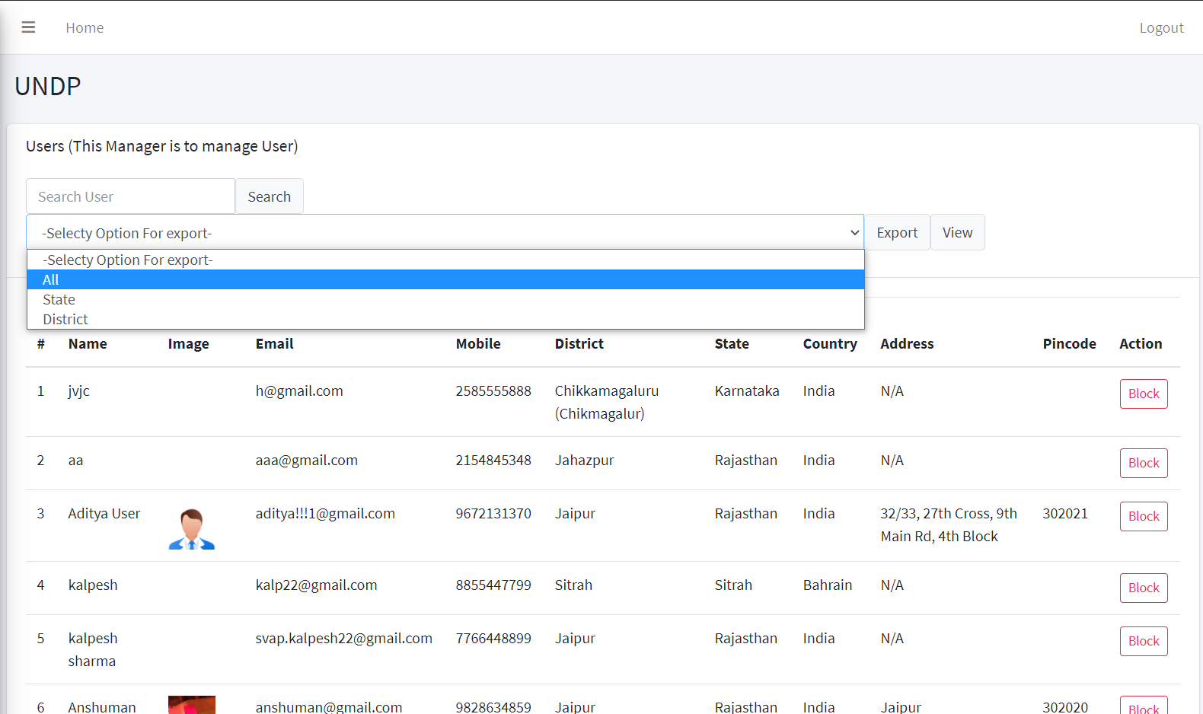

Step 2: After selecting All, click on View button, to view the list of all users then click on “Export” button to download the file in an excel sheet.

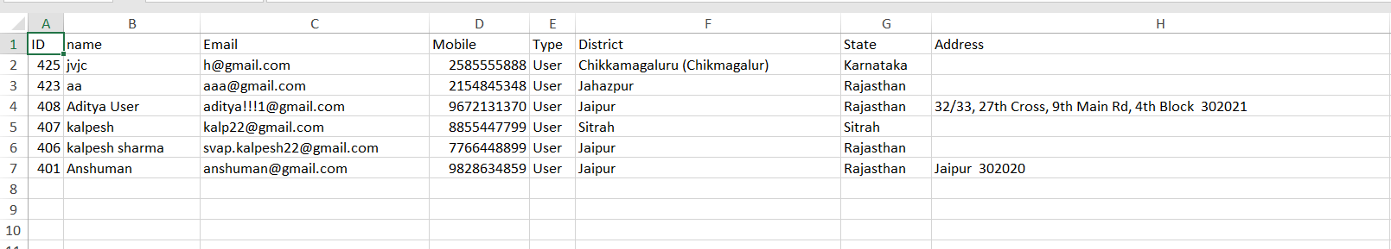

**State wise user data view/export**

This will export the list of registered users in the platform belonging to a particular state.

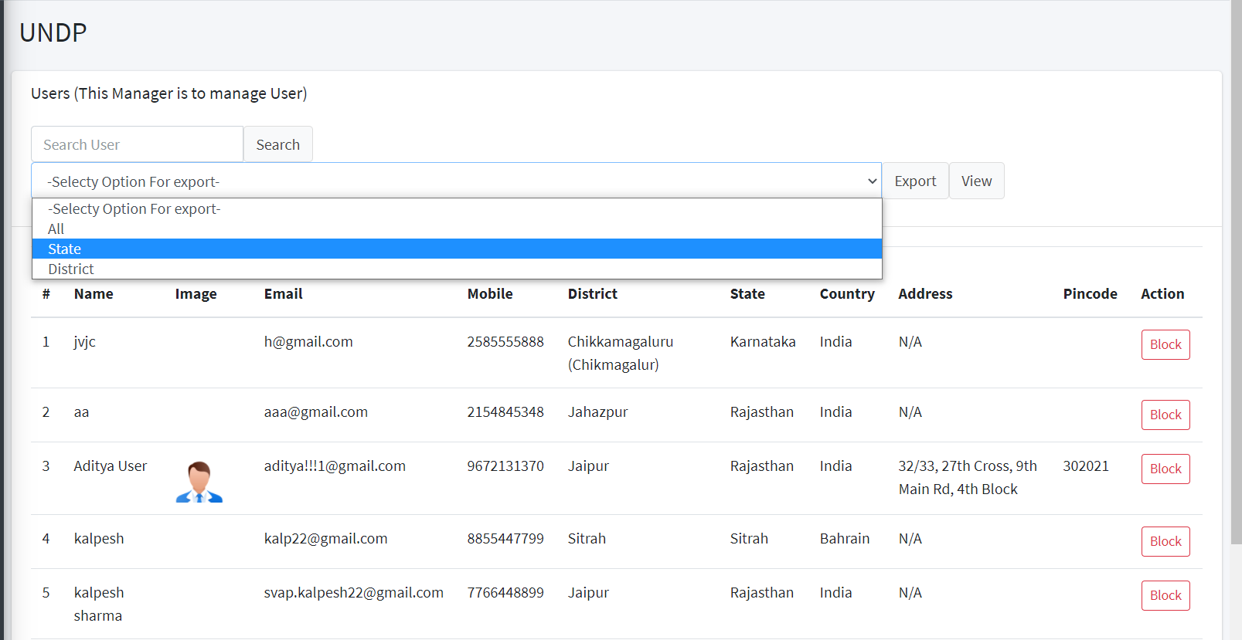Step 1: From “Select Option for Export” dropdown menu, select “State”

Step 2: From the “Select State” dropdown menu, choose the state for which you want to view/export data for.

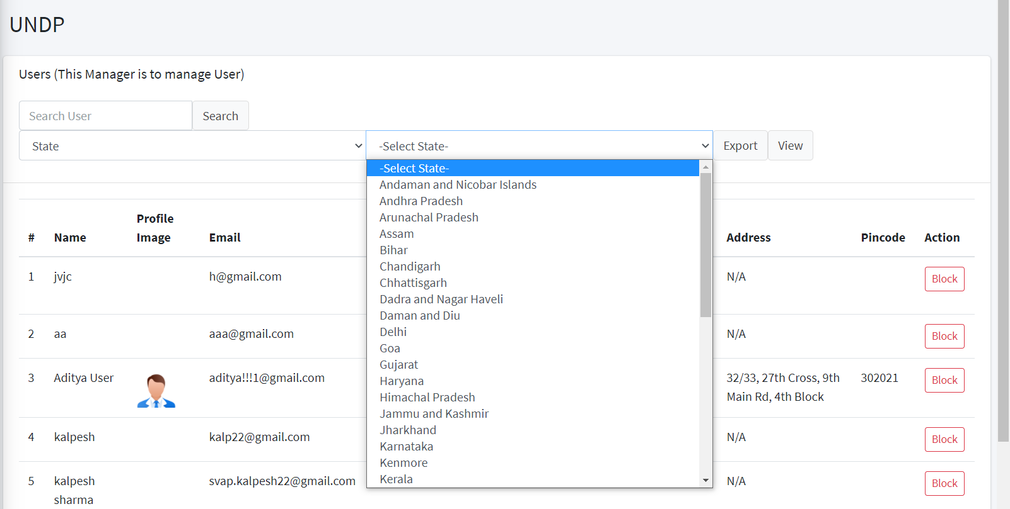

Step 3: After selecting state, click on “View” button to view the list and click on “Export” button to export the list in an excel file.

**District wise user data view/export**

This will export the list of registered users in the platform belonging to a particular district.

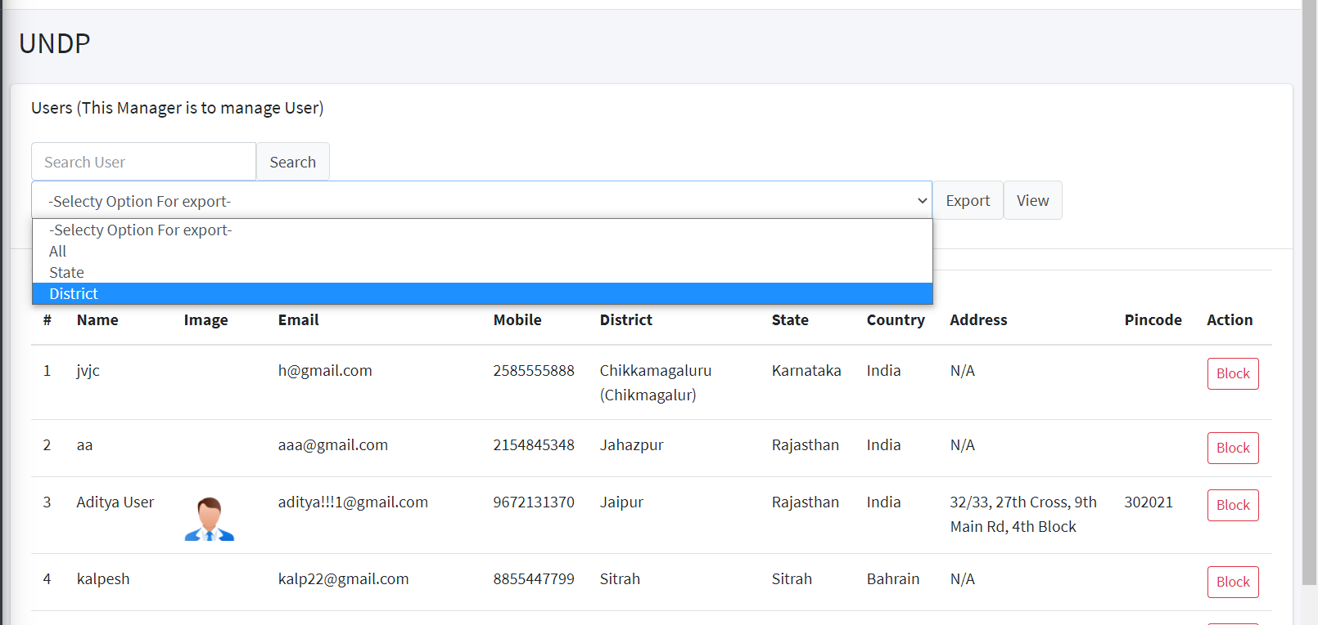Step 1: From “Select Option for Export” dropdown menu, select “District”

Step 2: From the “Select State” dropdown menu select the state

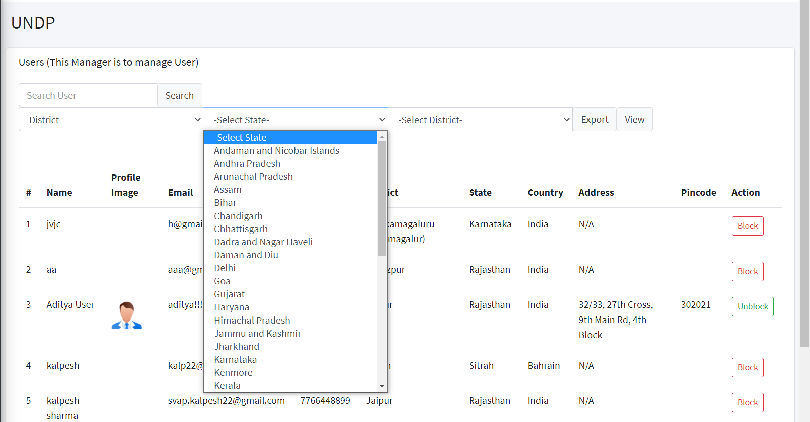

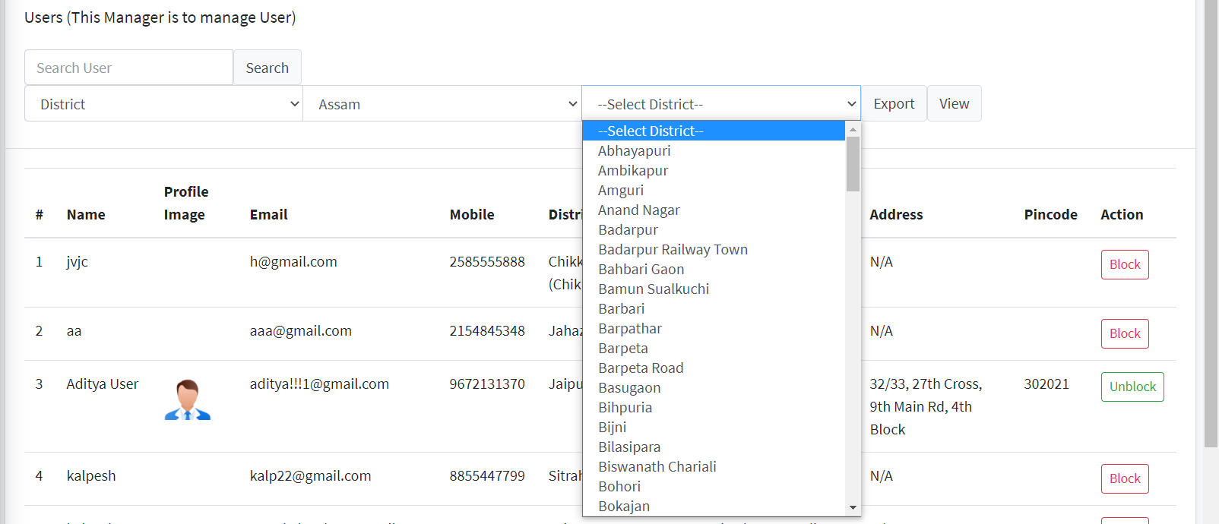Step 3: After selecting state, select district from “Select District” dropdown menu

Step 4: After selecting district, click on View button to view the list and click on Export to export the list in excel format.

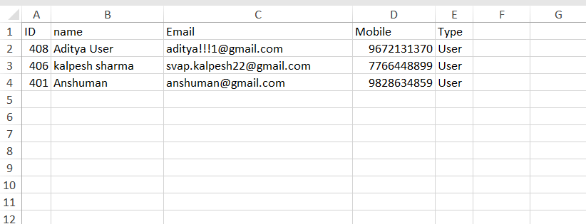

## Product Management

* Admin can search and export data of any product(s) present in the platform as per the different filters, in excel format.
* Admin can View/Edit/Disable any product from product manager.

Search Bar

Export Option

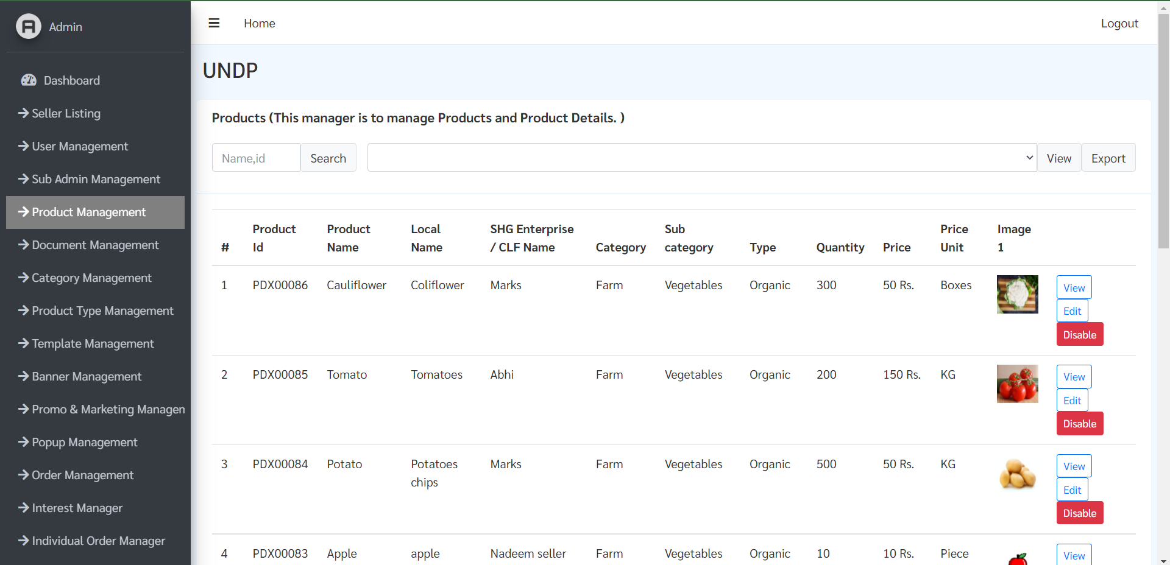

### Export Product Data

Product data can be exported by selecting the following filters (dropdown menu) given below:

* **All products**: Export data of all products
* **Category wise:** Export data of all products under a specific category
* **Sub category wise:** Export data all products under a specific sub-category
* **Product Type wise:** Export data for a specific product type (Farm, Non Farm & Off Farm)

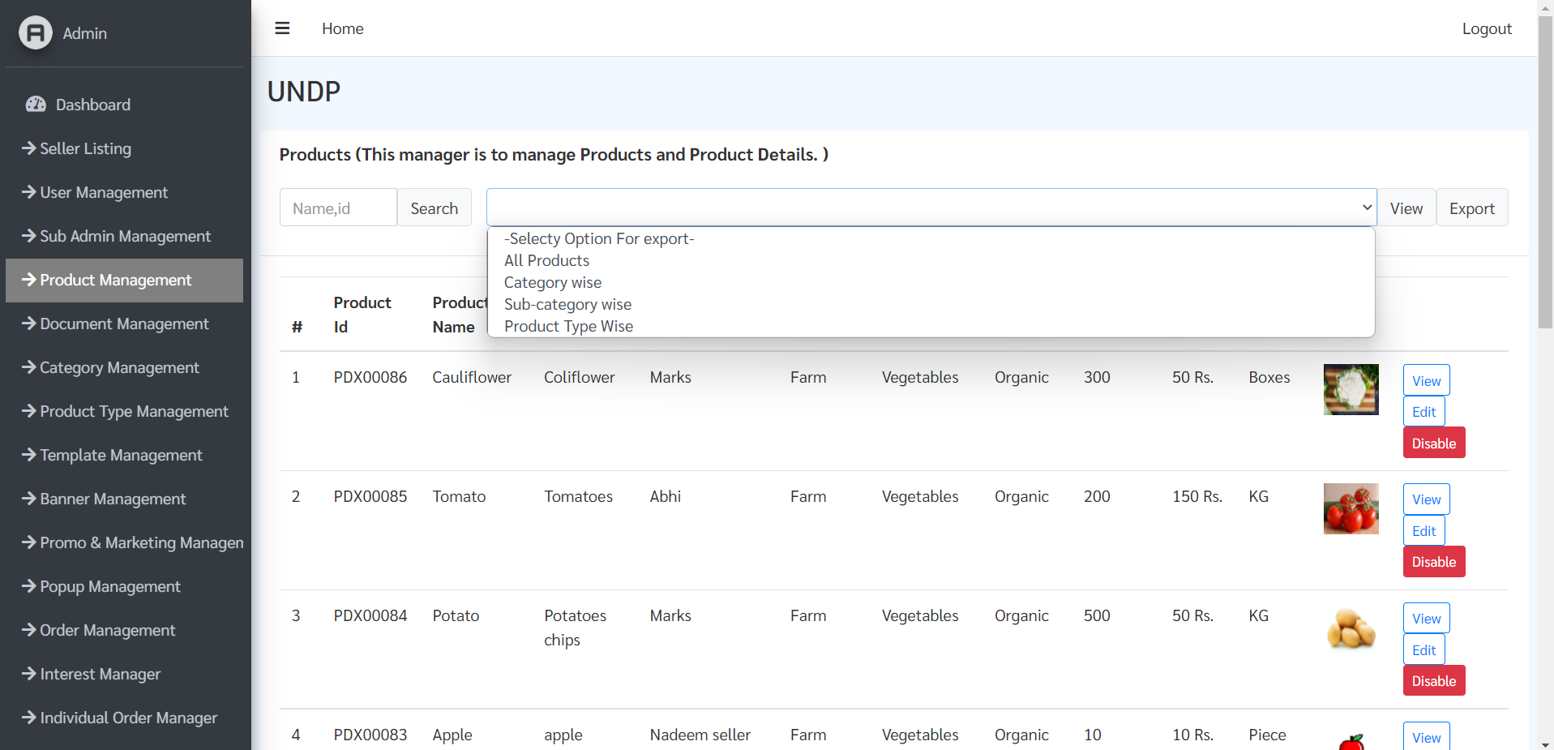

**All Product Export**

This will export the list of all Products uploaded in the platform and their details.

Step 1: Click on dropdown and select “All product” from dropdown

Step 2: Click on View to view them list of all products in the platform

Step 3: Click on export to download the list in excel file.

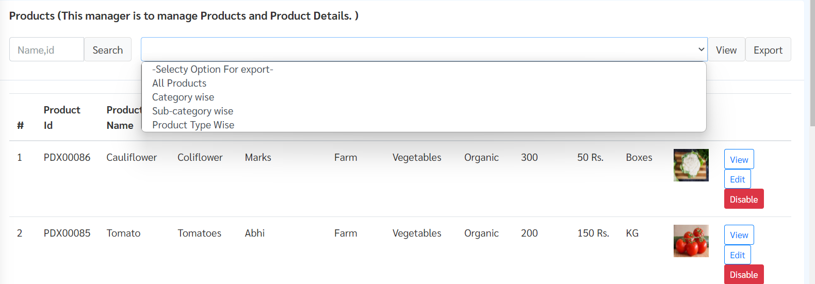

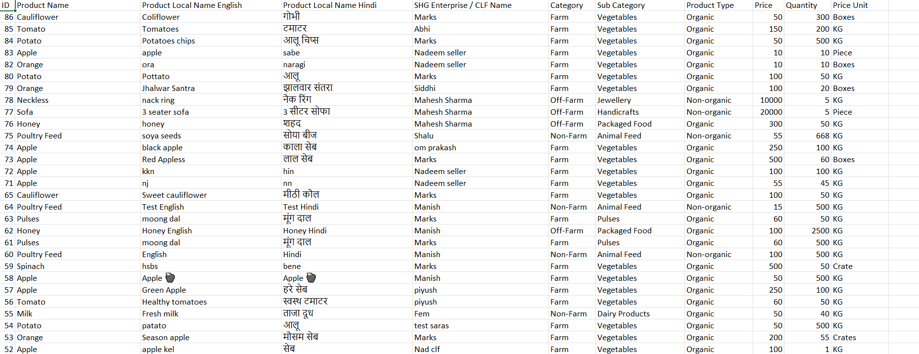

**Category Wise Data**

This will export the list of all products within a specific category in the platform

Step 1: To export list for a specific category, Select “Category Wise” from dropdown menu.

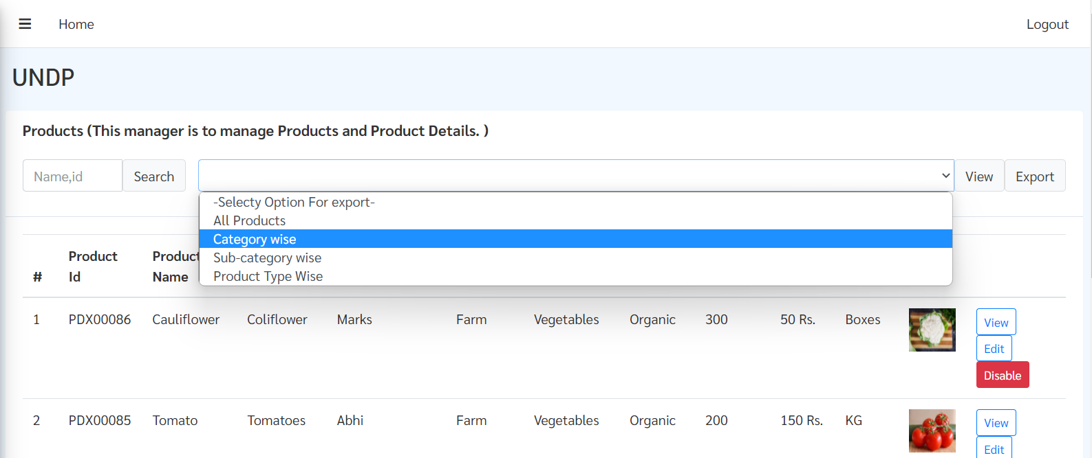

Step 2: After selecting “Category wise” option, select the sub-category from dropdown menu, then click on “View”.

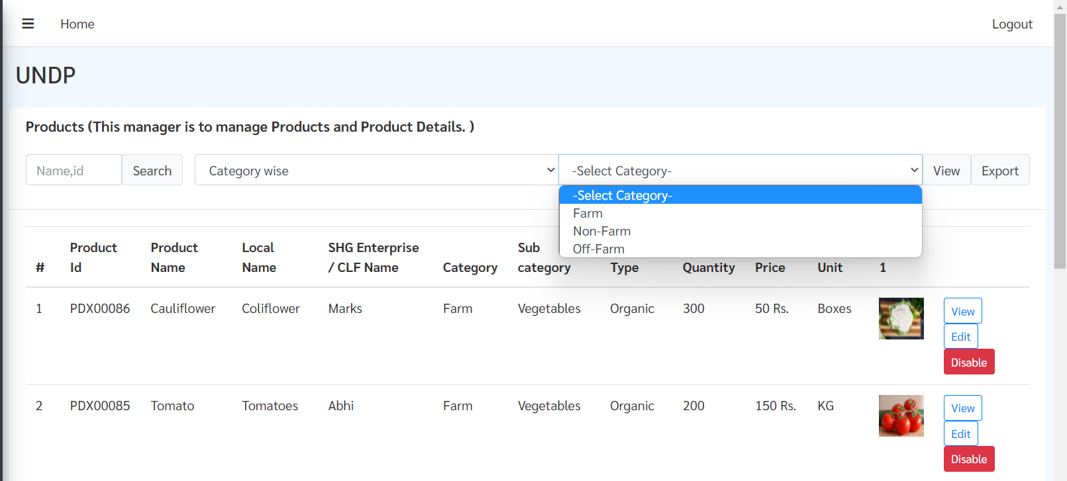

Step 3: When list of appears click on “Export” button, it will export the list in the excel file.

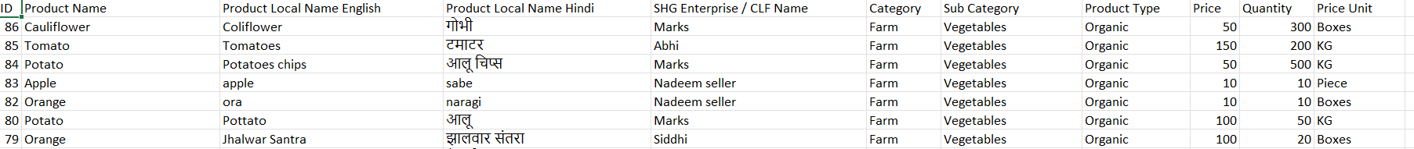

**Sub-Category Wise Data**

This will export the list of all products according to specific sub category in the platform.

Step 1: To export list of products for a specific sub-category, Select “Sub-Category wise” option from dropdown menu

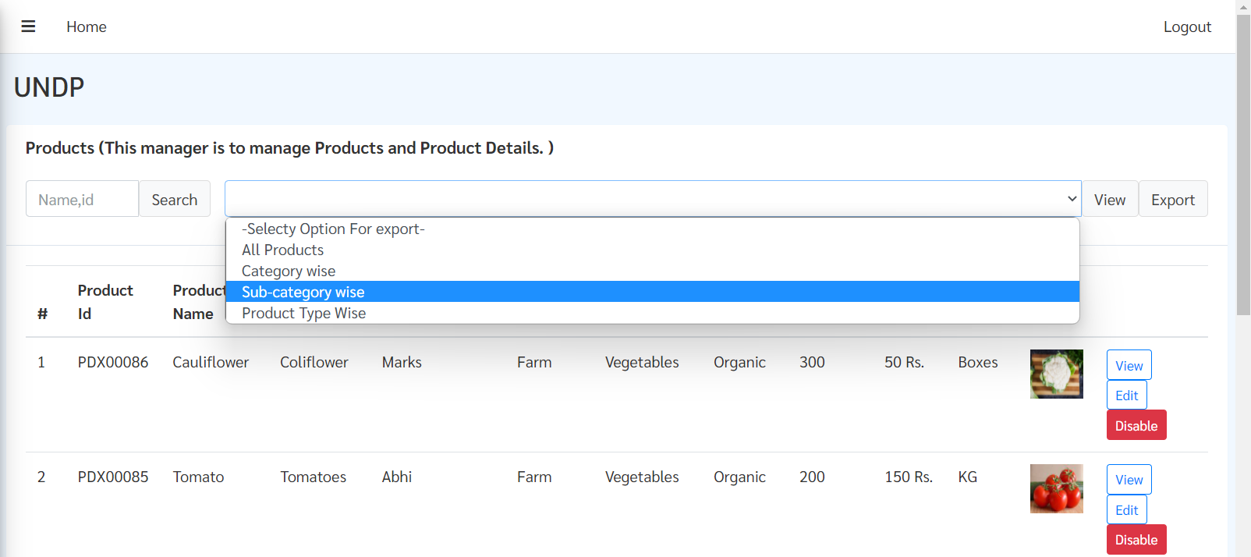

Step 2: After selecting “Sub-Category wise” option, select the specific category from list of all category in the dropdown menu.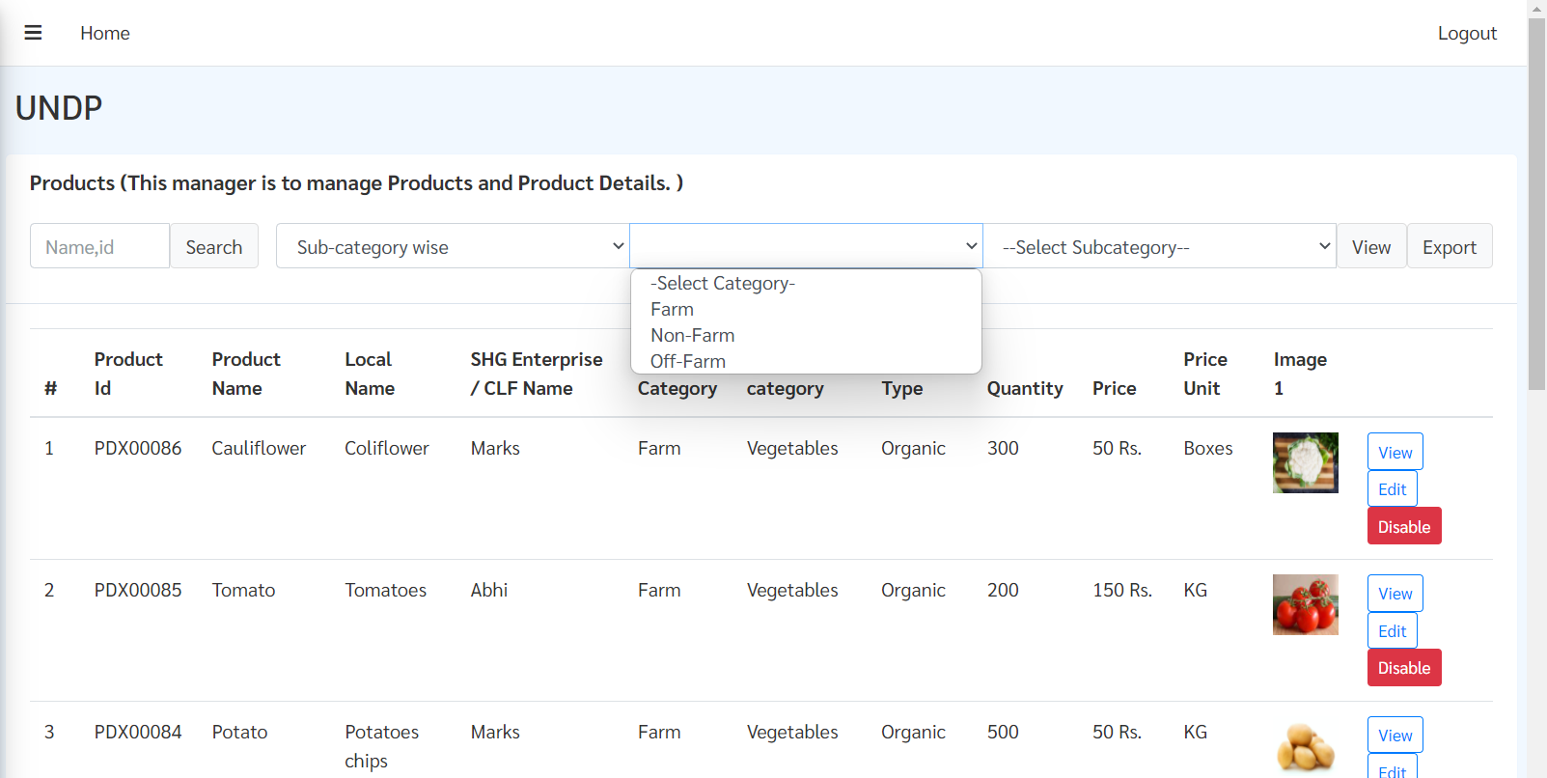

Step 3: Select Sub-Category from dropdown menu.

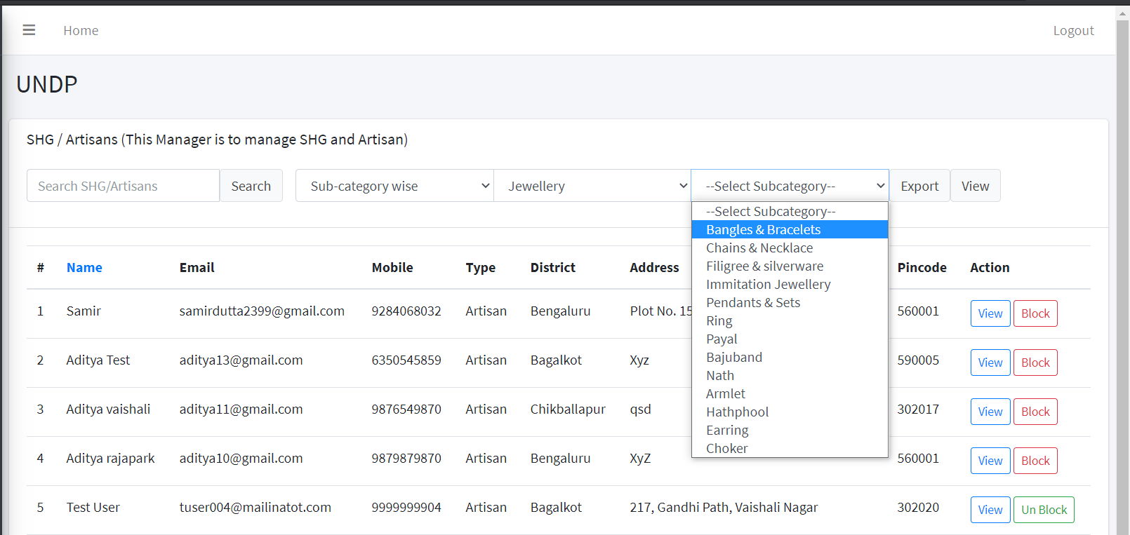

Step 4: After selecting sub-category, click on View button then click on Export to download the list in excel file.

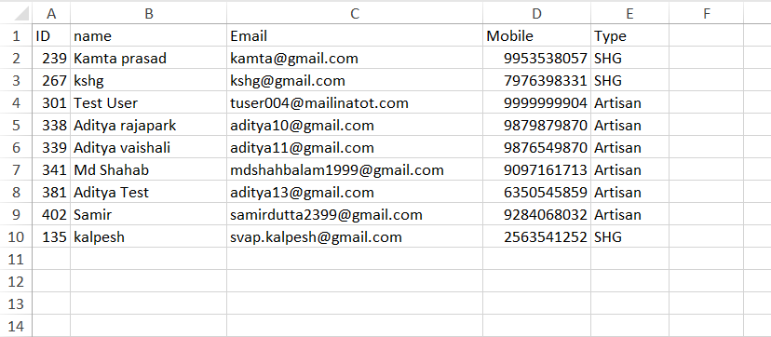

**Product Type Wise Data**

This will export the list of products for according to product type (Farm, Non Farm & Off Farm)

Step 1: To export list of all SHG/Artisan for a specific material within a category and sub-category. Select “Product material wise” from dropdown menu.

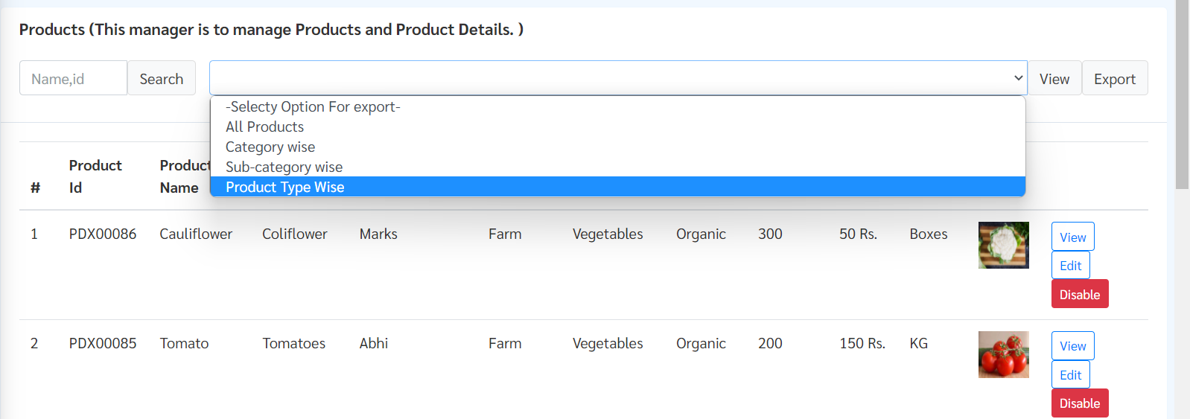

Step 2: After selecting “Product material wise” option, select the specific category from list of all category in the dropdown menu.

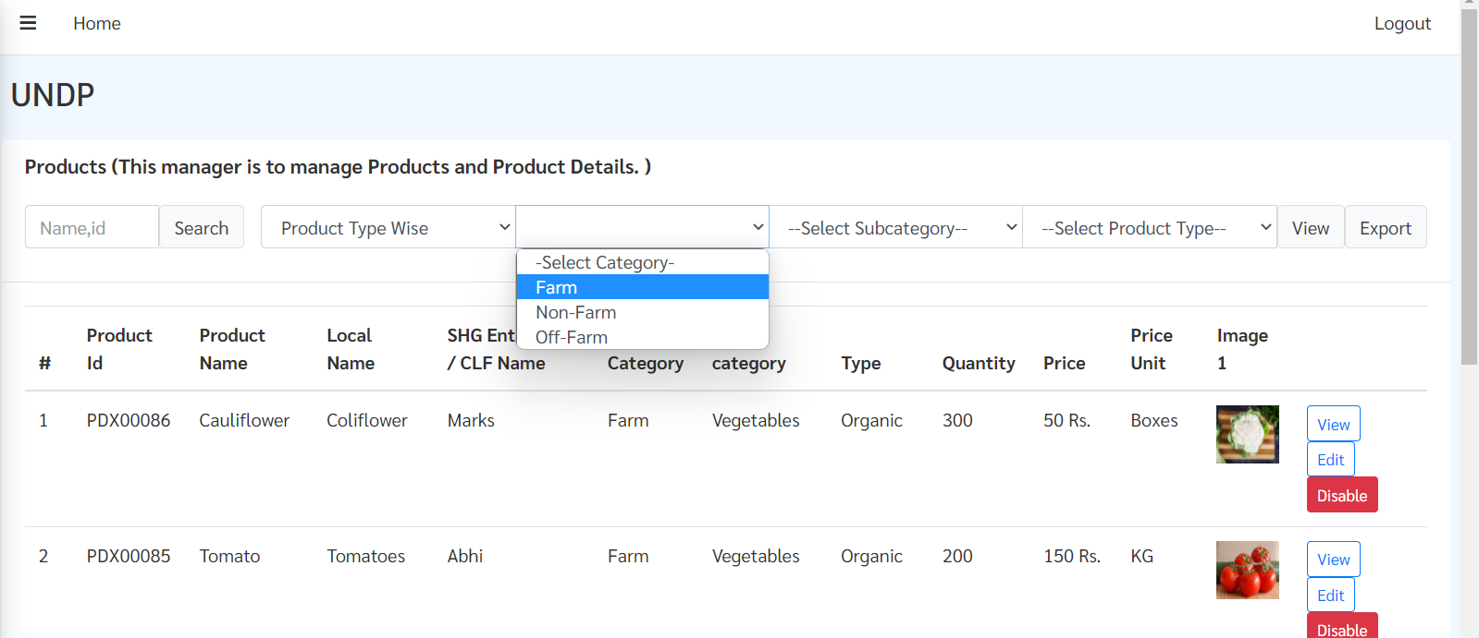

Step 3: Select Category & Sub Category from dropdown menu & select product type wise and click on View and then export.

### View/Edit/ Disable Product

**View list of product**

Step 1: The admin can view any product from the platform.

* All products: View all products
* Category wise: View products for a specific category
* Sub category wise: View products for a specific category and sub-category
* Product type wise: View product for a specific for specific product type (Farm/Non Farm/Off Farm)

Step 2: After selecting the specific filter from the dropdown, click on View button to view the respective list.

**View Product**

Step 1: To view details of a specific product detail, click on View button.

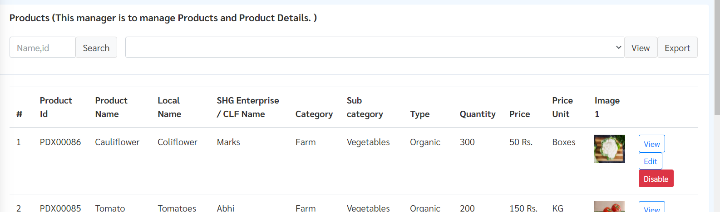

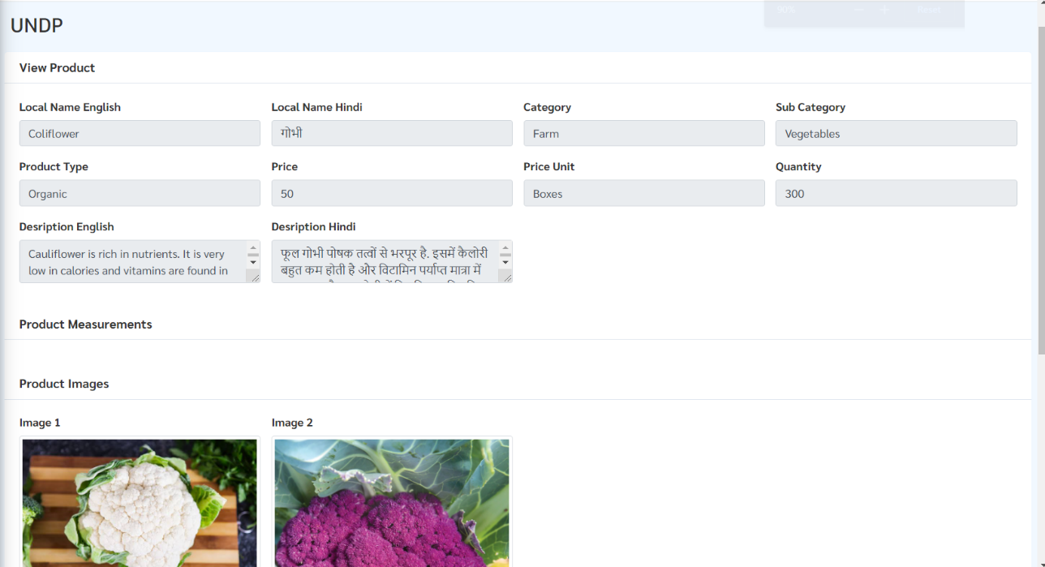

**Disable specific Product**

Step 1: To disable a specific product, click on “Disable” button next to the product.

**Note**- Once a product is disabled, then that product will not be available in the platform



To enable a disabled product click on “Enable” button next to it.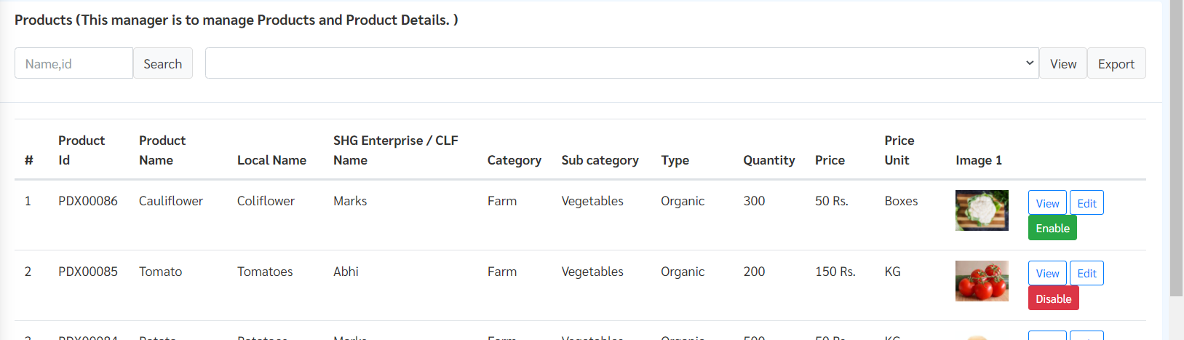

**Edit Product:**

Step 1: To edit product click on “Edit” button next to the product you want to edit.



Step 2: After clicking Edit button, product edit page will open here you can edit the following details of product.

* Product’s local name in English & Hindi
* Product’s Category, sub-category & material
* Product’s price & quantity
* Product’s description in English & Hindi
* Edit the values of measurement unit
* Change product images

Step 3: After making the necessary changes click on “Save Changes” button highlighted below.

### Document Management

In this section admin can view/reject uploaded documents of any registered SHG’s or CLFs

Step 1: Click on “View” button for any SHGs/CLFs to view uploaded documents

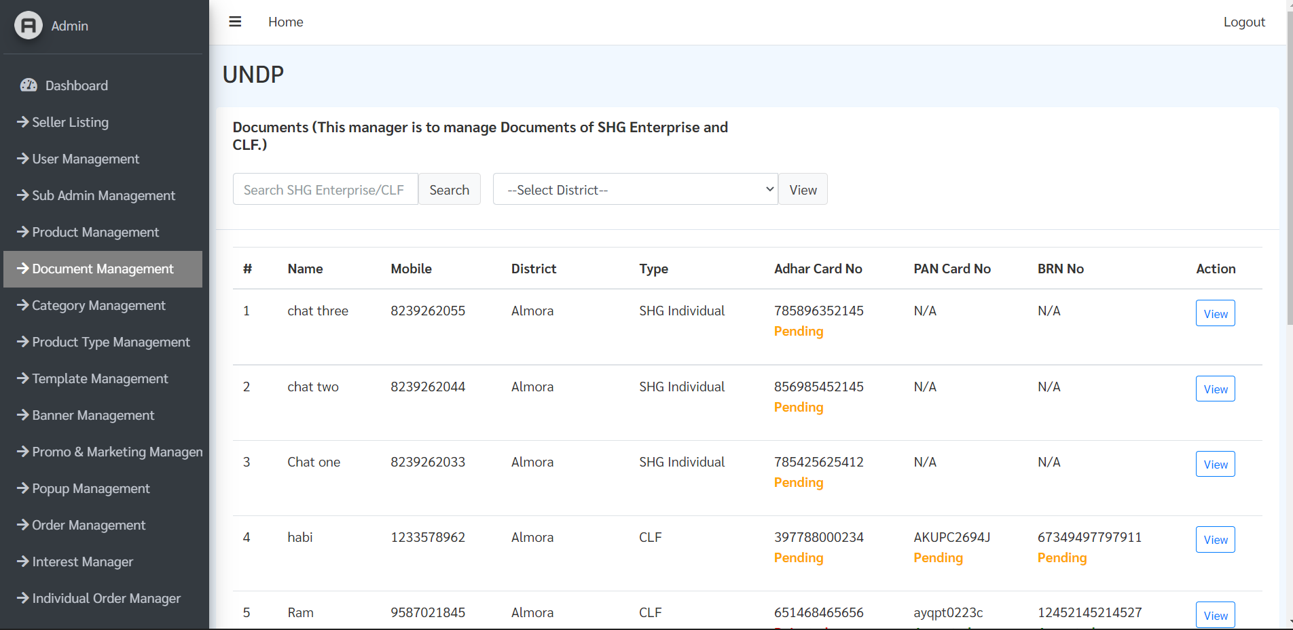

Step 2: Here all uploaded document of that SHG/CLFs can be viewed and if any document is found to be fake by admin, then he/she can reject that document by clicking “Reject” button.

**Note**- Once the document for any SHGs/CLFs are rejected then they can no longer add products in the platform and they will be prompted in the app with a message saying “Your documents has been rejected by admin, Kindly re-upload your documents”.

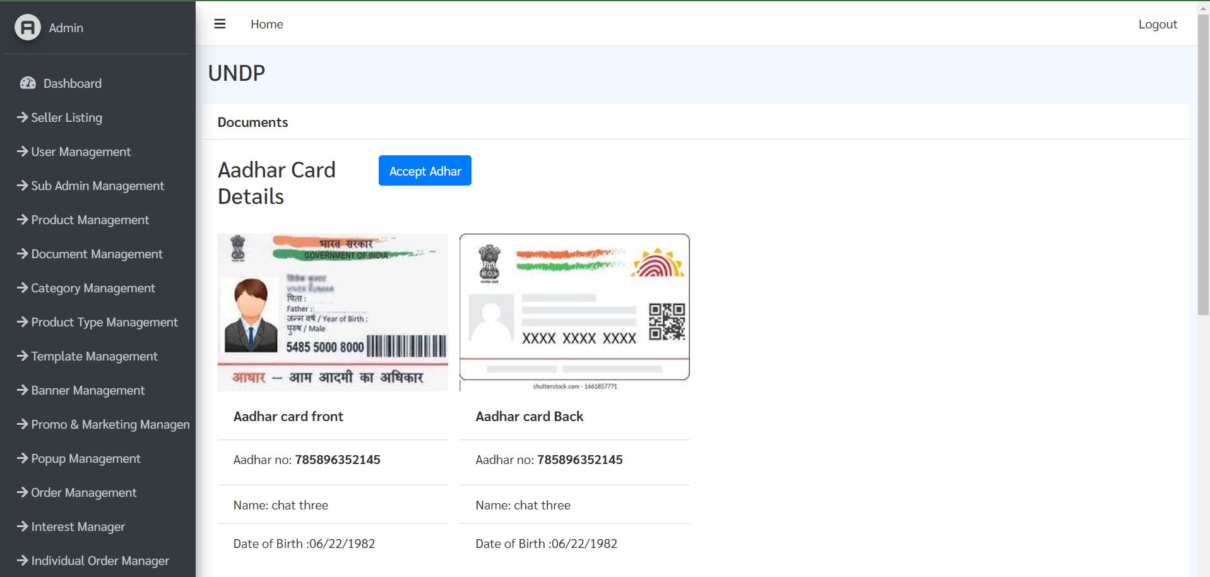

## **Section 3: Catalogue Management**

## Category Management

* Search for any specific category or sub-category
* Add new category
* Admin can View/Edit/Disable any existing category
* 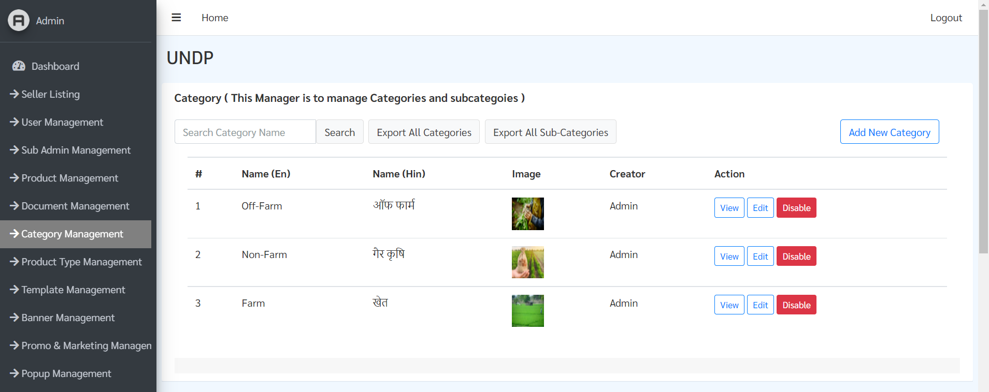Export details of all existing categories in excel document

Search Bar

### Add Category & Sub-Category

**Add Category**

Step 1: In the home page of Category Management, click on “Add New Category” button highlighted below.

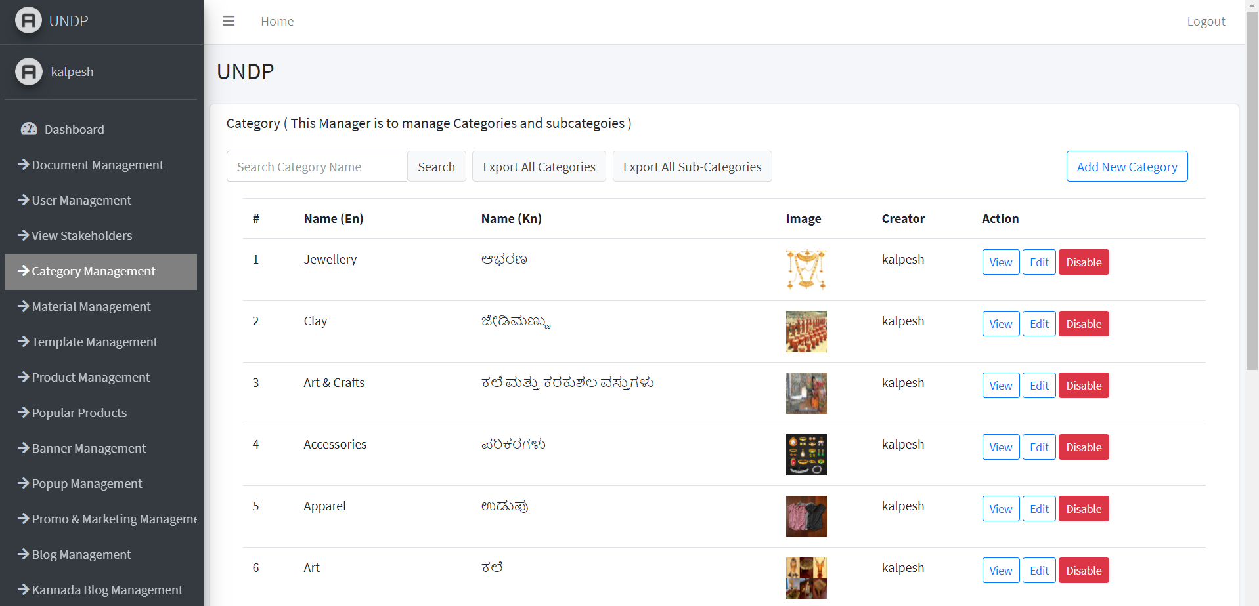

Step 2: Select “Add Category” radio button.

Step 3: Write the name of category in English & Hindi, choose display picture for category, then click on “Add Category” button.

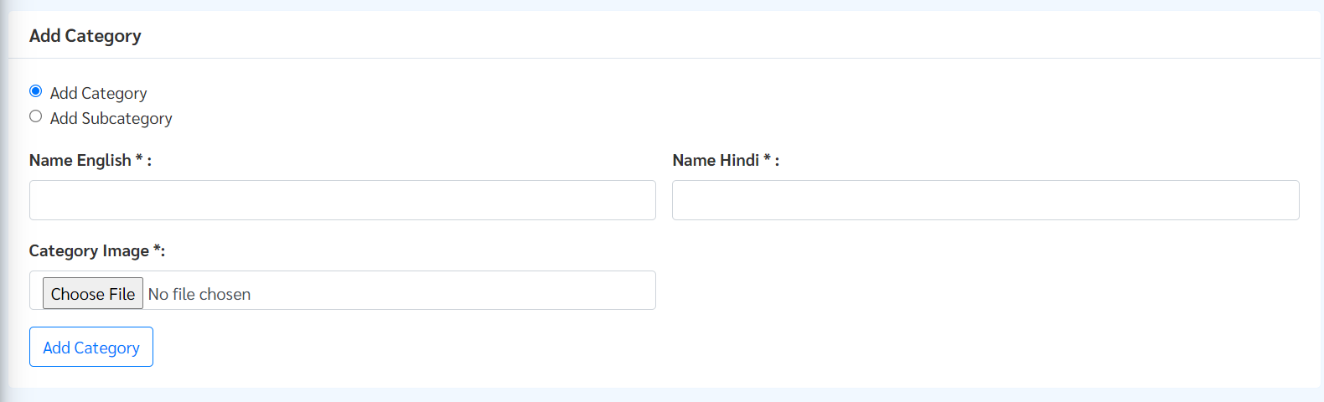

**Adding New Sub-Category**

**Option 1:**

Step 1: In the home page of Category Management, click on “Add New Category” button highlighted below.



Step 2: Select “Add Sub-Category” button.

Step 3: Write the name of sub-category in both English and in Hindi, upload display image for your sub-category then click on “Add Category” button.

**Option 2:**

Step 1: To add new sub-category click on “Add Sub-category” button on category page.

(to open category page, click on “View” right next to category in which you want to add sub-category *as shown above*)

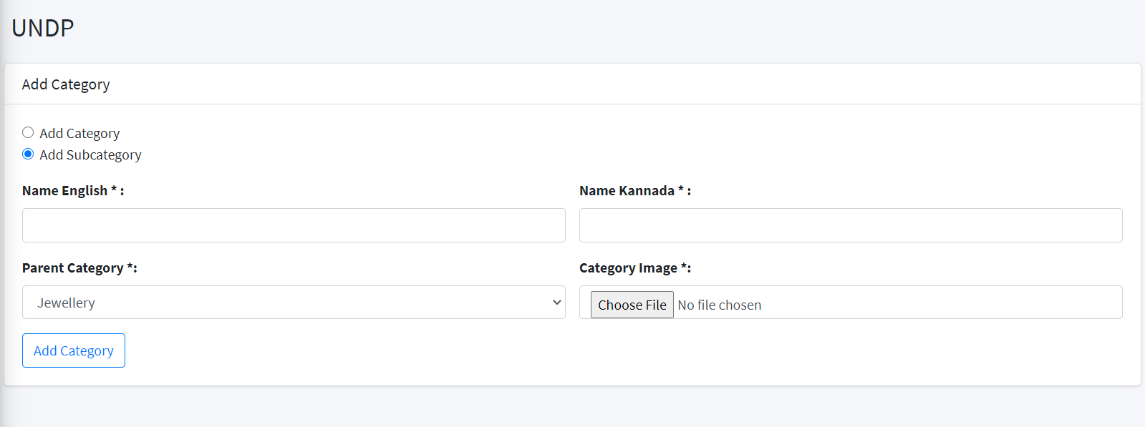

Step 2: Write the name of sub-category in both English and in Hindi, upload display image for your sub-category then click on “Add Category” button.

### View/Edit/Disable Category

**View Category**

Step 1: Click on “View” button for the category you want to view. Here you can view all the sub-category associated with that category.

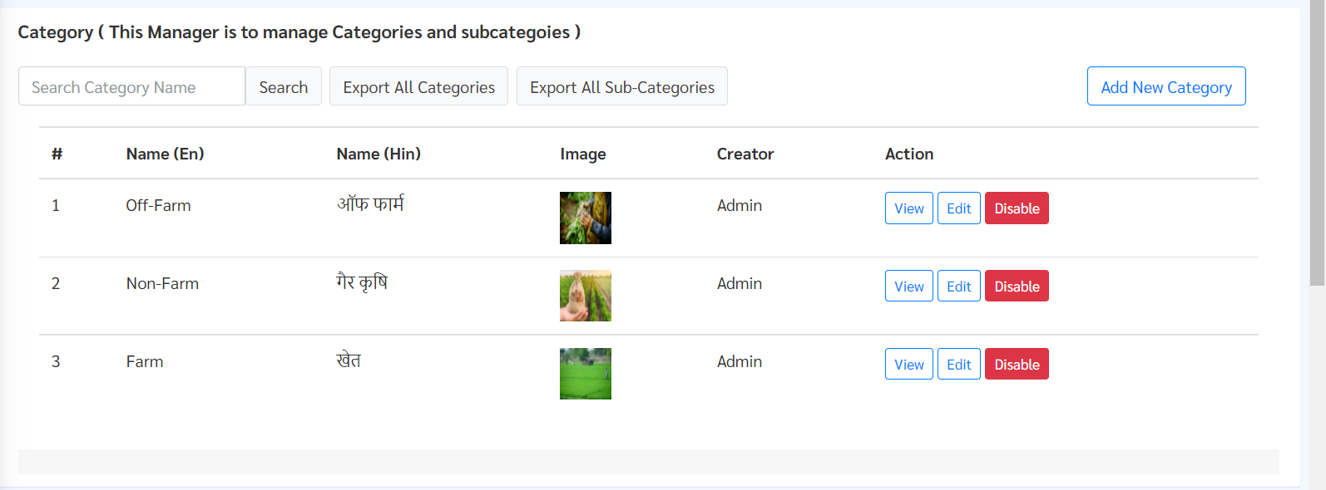

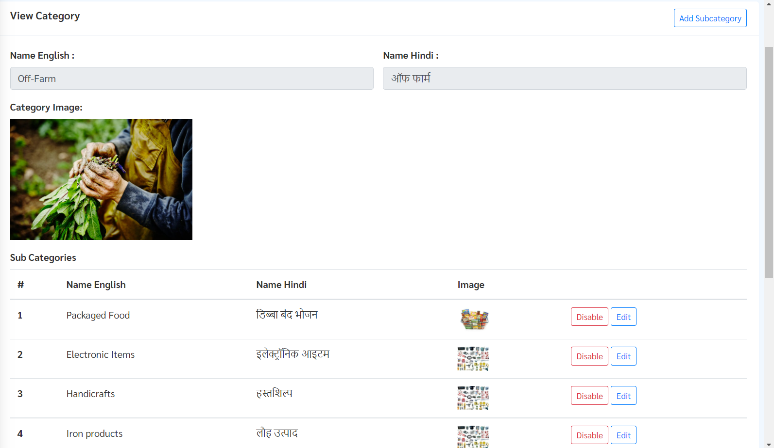

**Edit Category**

Step 1: Click on “Edit” button for the category you want to edit.



Step 2: Now you can edit information related to category i.e name in English and in Hindi, display image for that category.

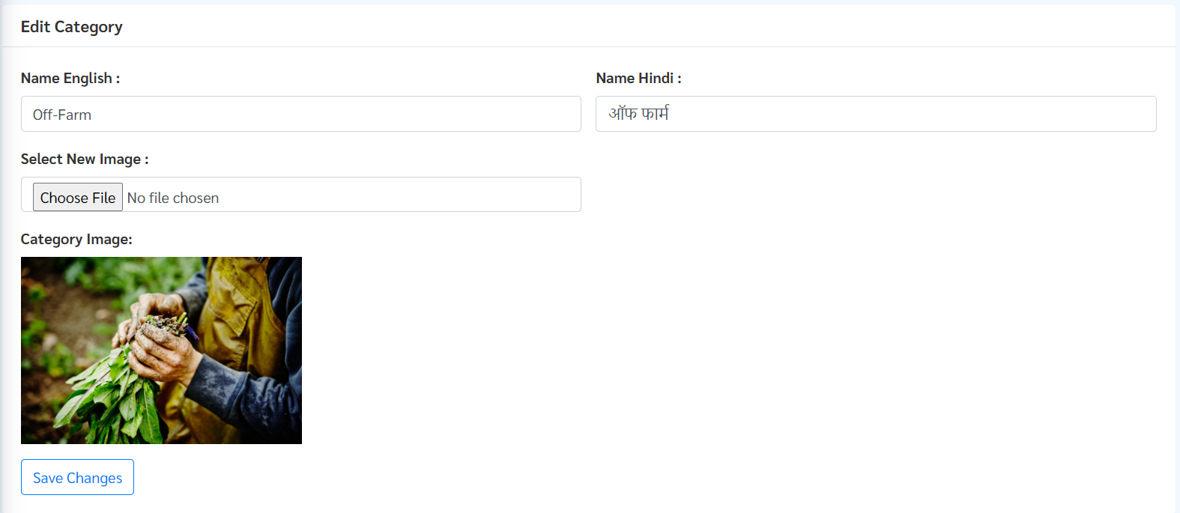

Step 3: After making necessary changes click on “Save Changes” button highlighted above.

**Disable Category**

To disable any category click on “Disable” button next to the category that you want to disable



Disabling Category will disable all Sub-Category within it as well as all products associated to that Sub-Category.



After Clicking “Disable” button a pop-up will appear asking to confirm your action.

Click “OK” to disable.

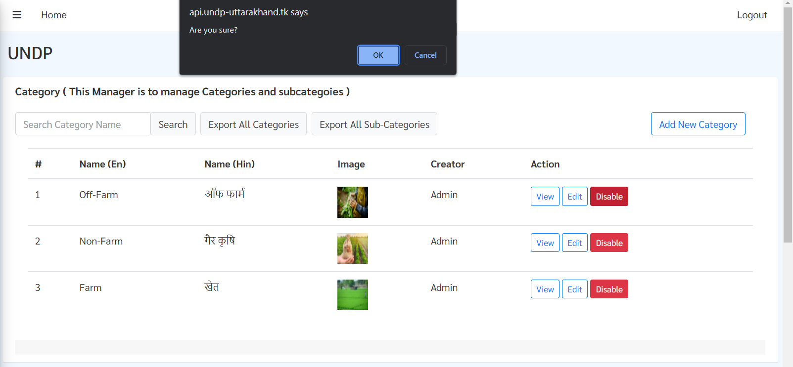

## Product Type Management

**Viewing product type**

Step 1: To view list of product type, click on “Product Type Management” module

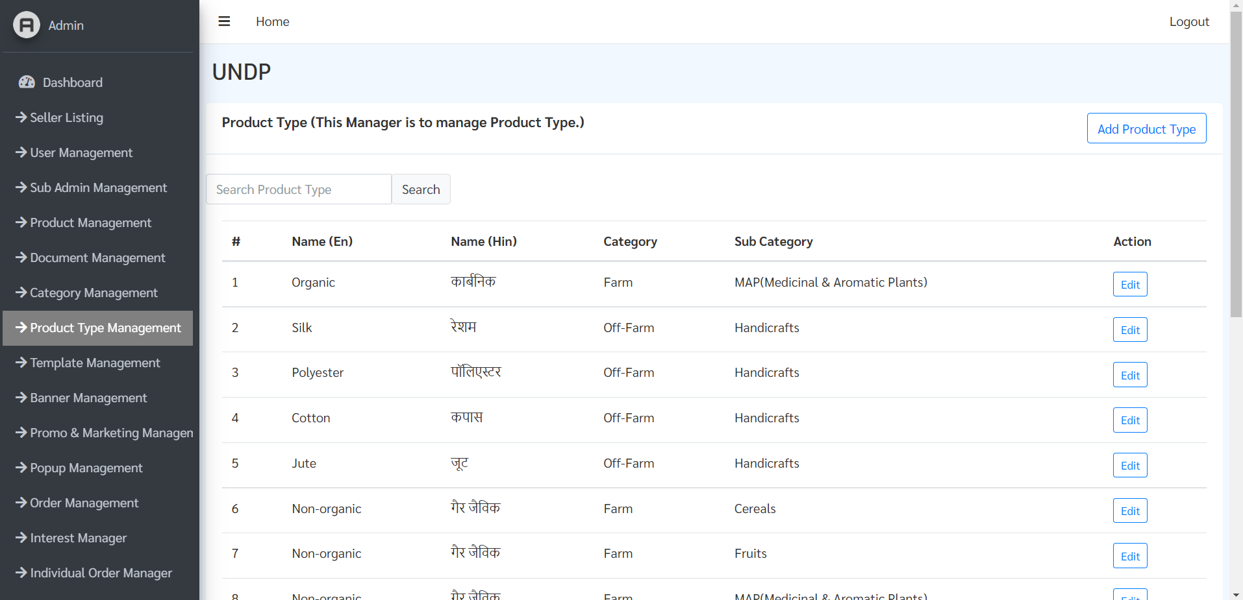

**Editing Product type**

Step 1: To edit product type, click on “Edit” button next to the product type from the list



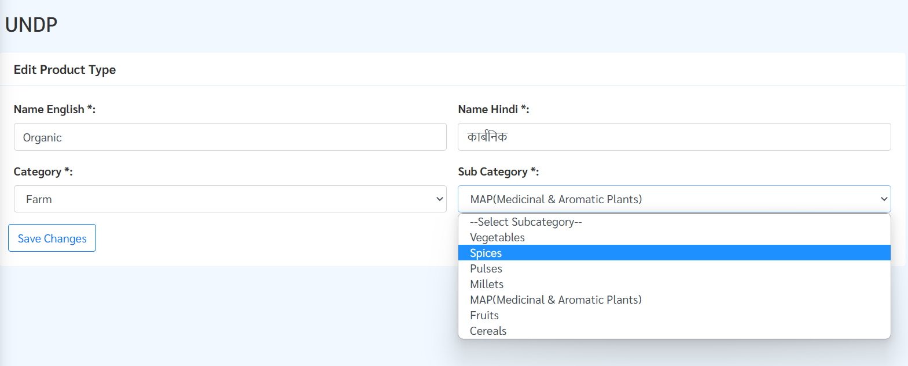

Step 2: Now you can edit Name of Product Type and change Category and Sub category, after making necessary changes click on “Save Changes” button

## Template Management

This module is to manage/create product templates in the platform.

**Features of this module:**

* Search any product template
* Export all templates
* Add new template in the platform
* Edit existing product template

**Product Template**:

A Product Template comprises of a specific Category, Sub-Category, Product Type, Measurements, Product Name & Description (in English & Hindi). These templates are designed to assist sellers while adding products, making the process easy since each template contains prefilled product name and description in both English and Hindi language.

**Attributes of a Template:**

* Category & Sub-Category: The Category (Farm, Non Farm & Off Farm) and Sub-Category a product belongs to.
* Material: The material mapped to the selected category and sub-category.
* Measurements: The Measurements for a particular product. The Artisan/SHG can then add the respective value of the selected measurements:
  + Height
  + Width
  + Length
  + Volume
  + Weight
* Product Name & Description (EN, HN): Writing the Product name and Description for the specific product within the Category, Sub-Category and Material.

Category

Sub-Category

Product Type

Measurements

Product Name & Description (EN, HN)

Product Template

**Search any product template**

Step 1: You can search a particular product template by entering either – Name in English or Hindi in the “Search Template Name” search bar and hit “Search” button.

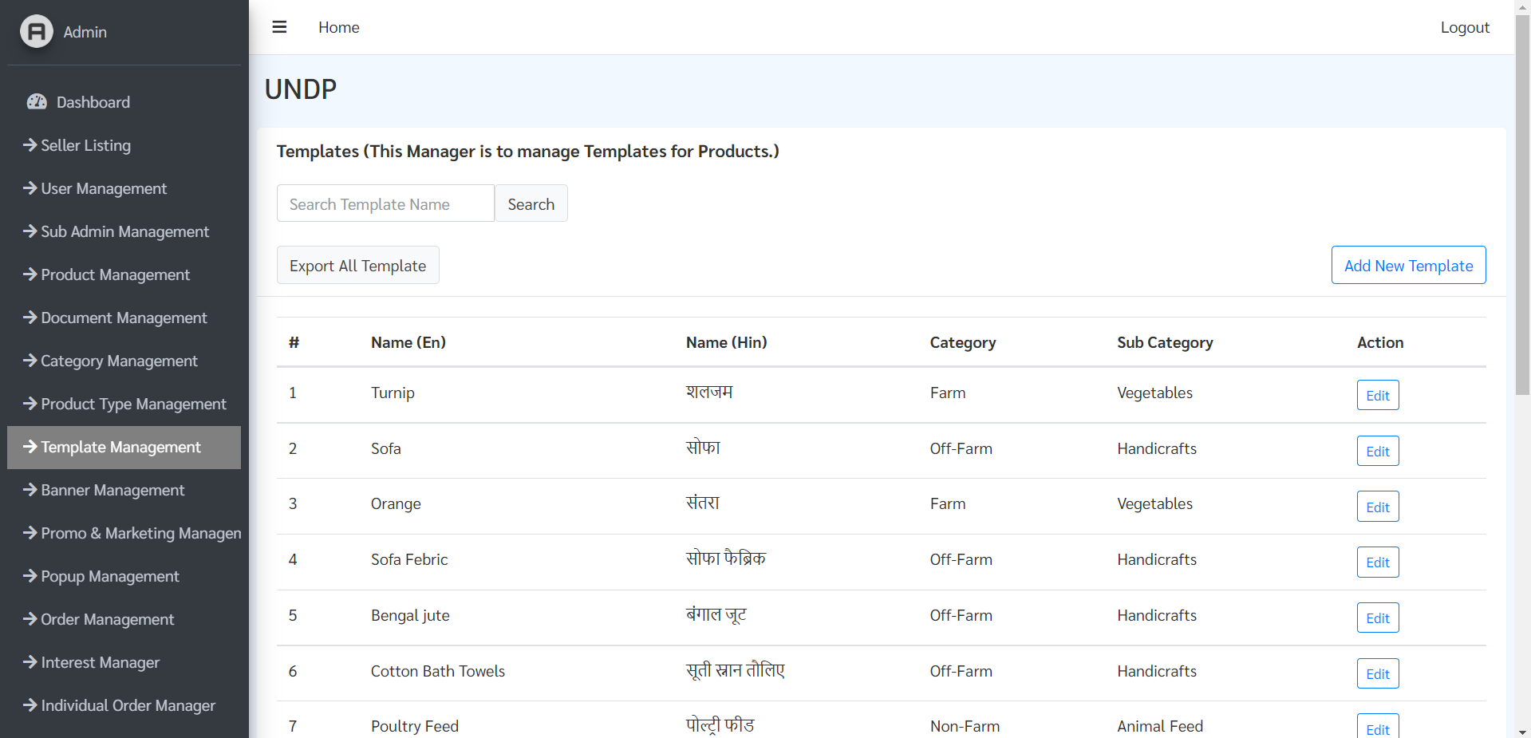

**Export all Templates**

Click on “Export All Template” button highlighted above.

### Add New Template

Step 1: To add new product template click on “Add New Template” button highlighted below.

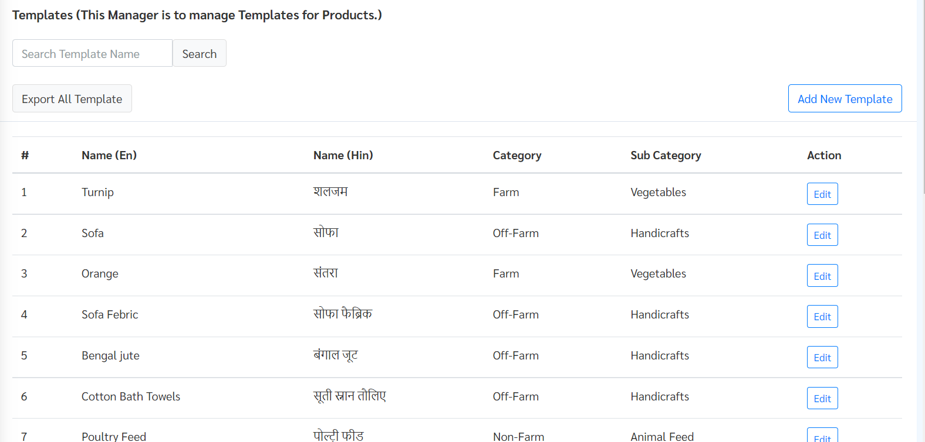

Step 2: Select category, sub-category, material from dropdown list.

Step 3: Write product name in English & in Hindi.

Step 4: Select relevant measurement units for the product.

Step 5: Write product description both in English & Hindi language.

Step 6: After filling all the attributes, click on “Add Template” button highlighted below.

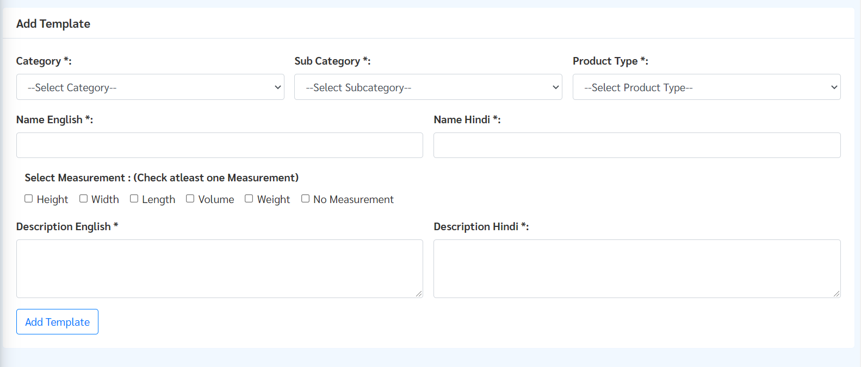

### Edit a Template

Step 1: Click on “Edit” button for the template you want to edit.



Step 2: Make changes in the displayed fields.

Step 3: Click on ”Save Changes” button highlighted below.

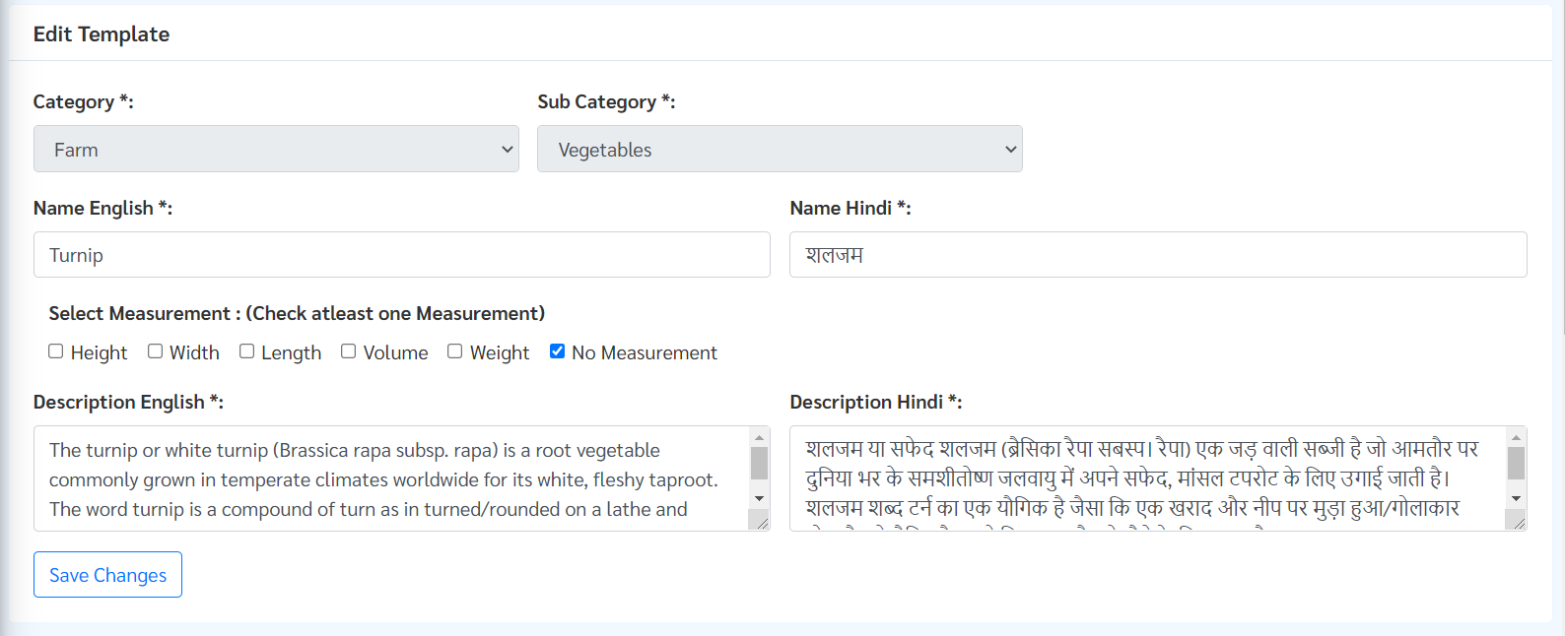

# **Section 4: Marketing & Promotion Management**

## Banner Management

This section is to manage Banners in the platform, here admin can view all banners, edit existing banner, add new banner, activate/deactivate and delete existing banner.

Banners are images which will be displayed on the Ajeevika landing page and in the mobile app as shown below. These banners are clickable and will redirect to the link added by the admin while uploading a banner.

**View Banner:** All existing banners in the platform will be displayed in the Banner Management module in a list highlighted below.

### Add New Banner

Step 1: To add new banner click on “Add New Banner” button highlighted below.

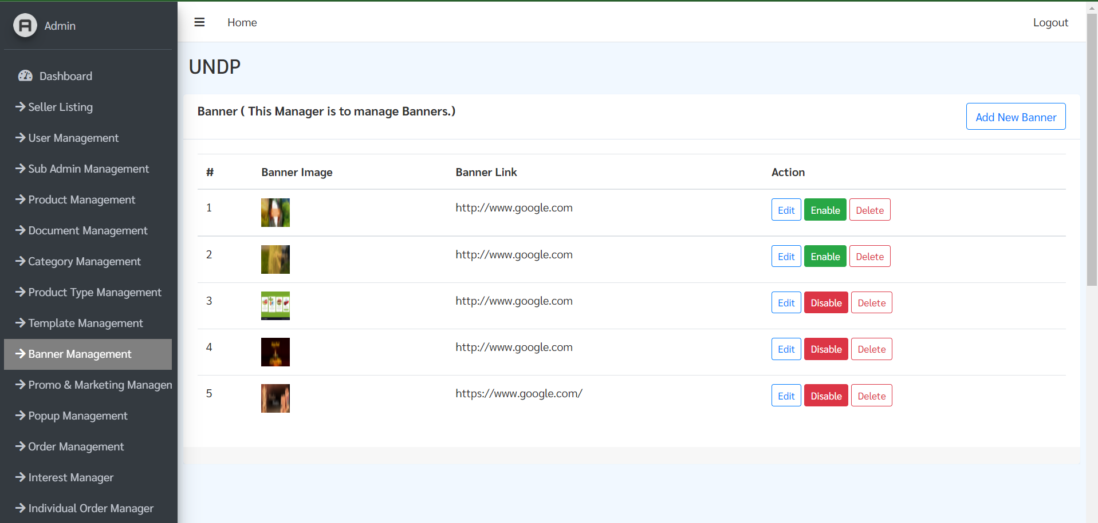

Step 2: After clicking on Add New Banner button, a new page will appear.

Step 3: To add the banner, upload a high-quality image for banner by clicking

“Choose File” button, then add link to the banner in “Banner Link” section.

**Note**- Link should start with http:// or https://

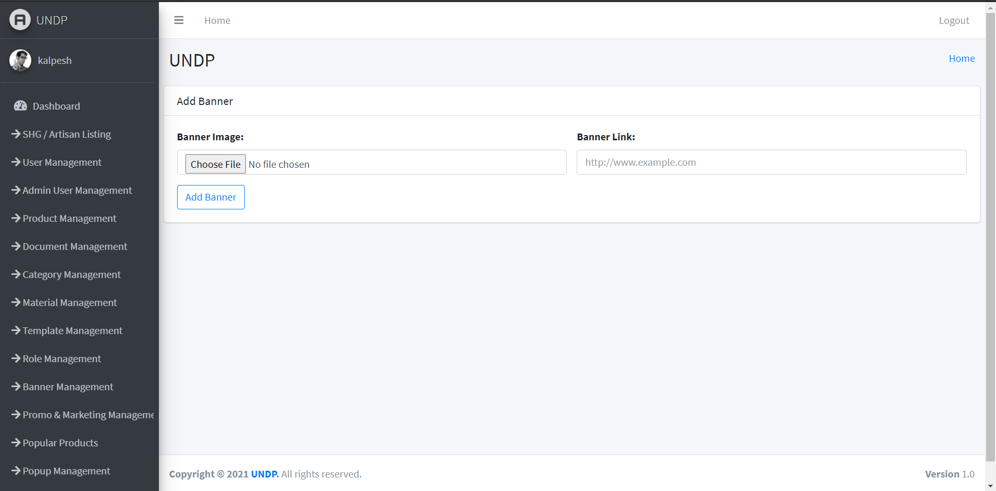

Added banner will be displayed in Banner section of Ajeevika Website as well as in mobile app highlighted below.

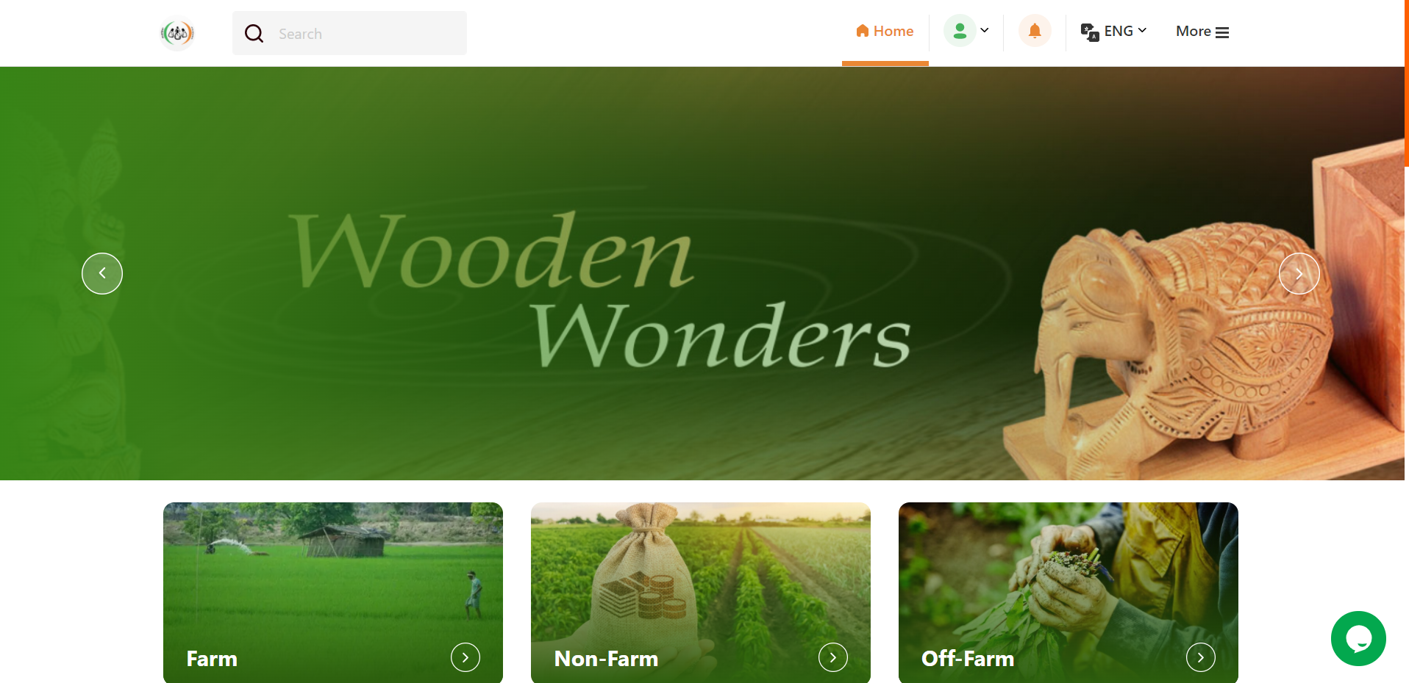

### Edit Banner

Step 1: To edit banner, click on edit button for the specific banner you want to edit.



Step 2: By clicking Edit button, banner edit page will open, here you can change image or change link as shown in Edit Banner section below.

Step 3: After making the necessary changes click on “Edit Banner” button highlighted below.

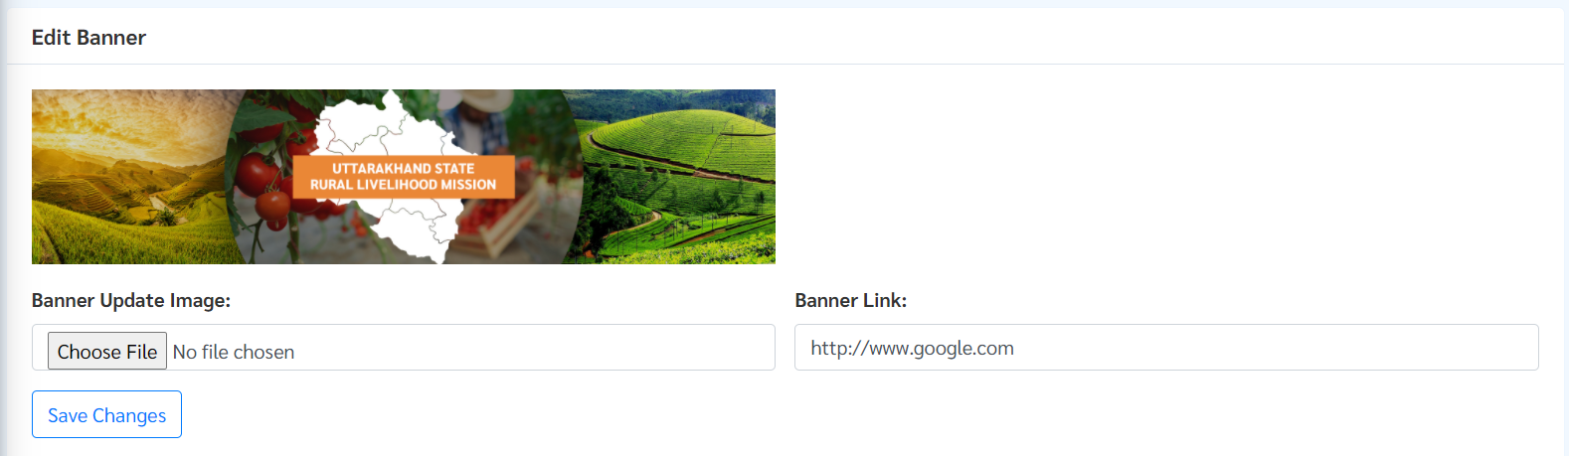Deactivate/Delete Banner

To deactivate an existing banner, click on “Activated” button next to the banner and vice-versa to activate an existing banner.

To Delete existing banner, click on “Delete” button.



## Popup Management

This section is to manage Pop-ups on the website. Pop-ups appear for the first time a user opens the Santhe web portal and mobile app (shown below). The purpose of Popups is to shoot ads, upcoming events or major announcements to the consumers and users, sellers, collection centres & SHG Individuals.

**Note**: At a given time only one pop-up can be active.

**Features:**

* Add New Popup to the website.
* Admin can View/Edit/Enable/Disable/Delete existing pop-ups.

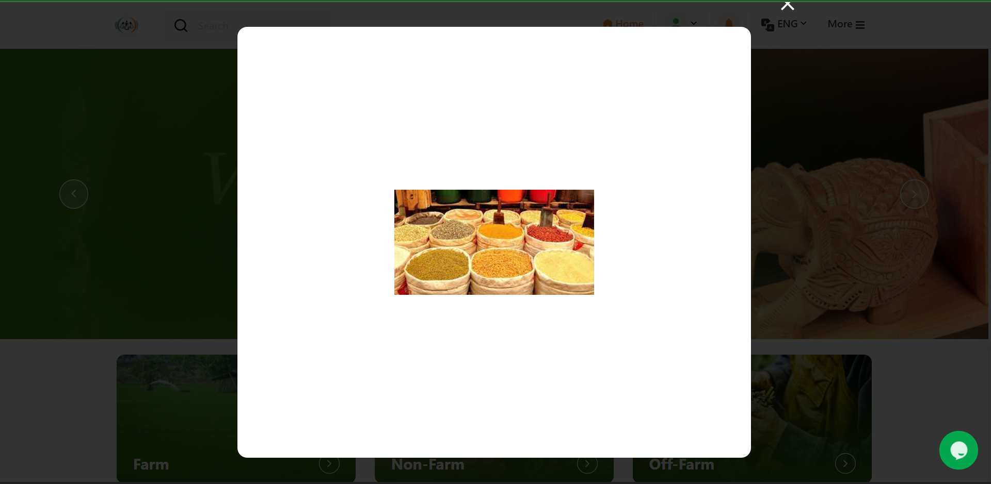

### Add New Pop-up

Step 1: Click on Add New Popup button on top right corner of screen.

Step 2: Add Title for popup.

Step 3: Select “Language” – English or Hindi

Note: The pop-up will only appear in the Ajeevika Web Portal and Mobile app for the selected language version. E.g. If Hindi is selected it will appear in the Hindi version of the landing page.

Step 4: Select “Role”:

* Users: Selecting “Users” as role would mean, the popup is only shown to the registered Users in the Ajeevika web platform and mobile app.
* CLF- Sellers registered as CLFs and SHG individual
* SHG Enterprise

Step 5: Upload Background Image.

Step 6: Click on “Add Popup”.

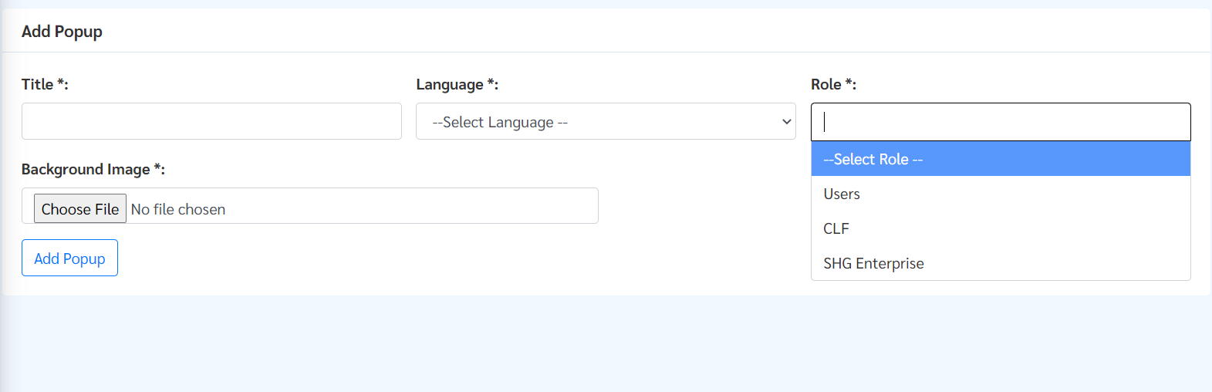

### View/Edit/Enable/Disable/Delete pop-ups

All the popups can be viewed from the list shown in Popup Management Module.

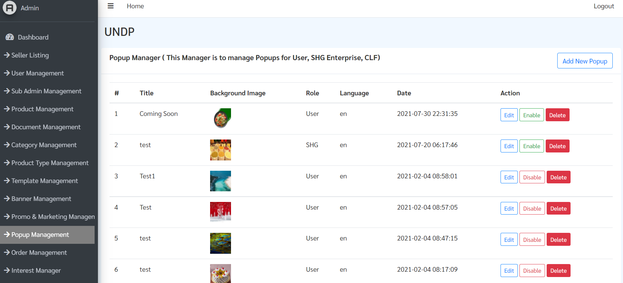

**Edit Popups**

Step 1: Click the “Edit” button for the specific Popup you want to edit.

Step 2: Change any of the following fields as desired - Title, Language, Role, Background Image.

Step 3: Press “Save Changes” button.

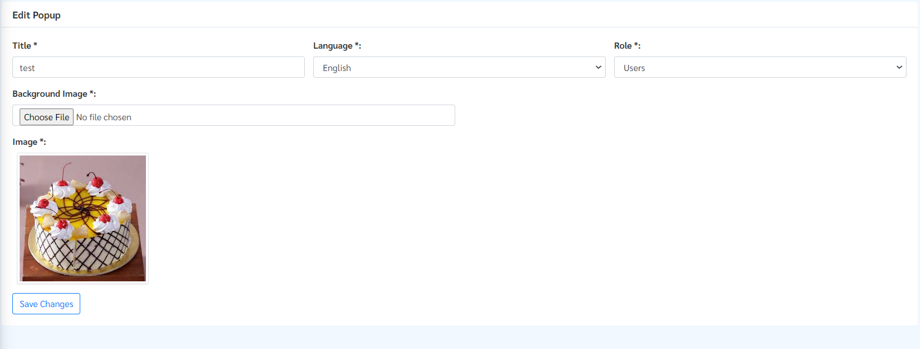

**Enable/Disable Popups**

Step 1: Click the “Disabled” button for the specific banner you want to enable and vice versa to disable, click on the “Enabled” button.



**Delete Popups**

Step 1: Click the “Delete” button for the specific banner you want to delete.

Step 2: A prompt will appear requesting your confirmation, press “okay” to confirm deletion.



## Promo & Marketing Management

This section is to manage Push Notifications, Bulk SMS and Bulk Email for User, SHG, Artisan.

* Admin can view all notification history, date and time of creation of notification and the role (stakeholder), the notification was created for.
* Admin can send Push Notification, Bulk Message and Bulk email to Users, CLFs, SHGs.

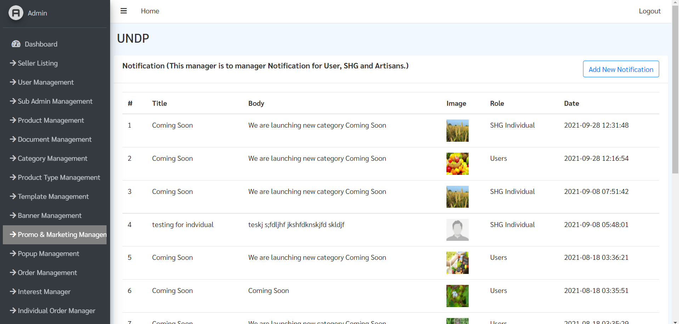

### Sending Push Notification

Step 1: Click on “Add New Notification” button, highlighted above.

Step 2: Add notification Title, Body, choose language from drop down menu.

Step 3: Select the “User Role” whom you want to send notification to (Users, SHGs, Artisan).

Step 4: Select image (this is optional).

Step 5: Click on “Add Notification” button.

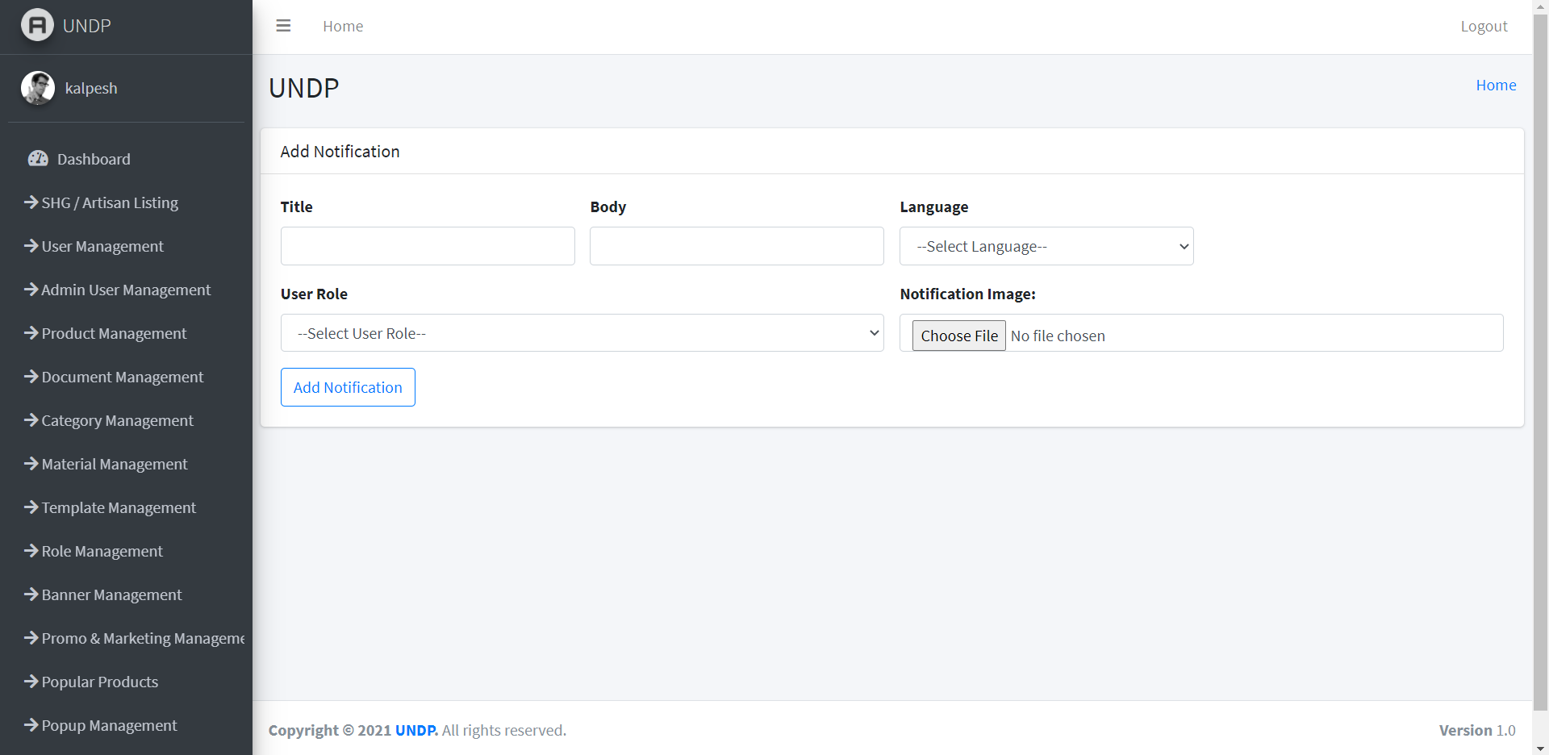

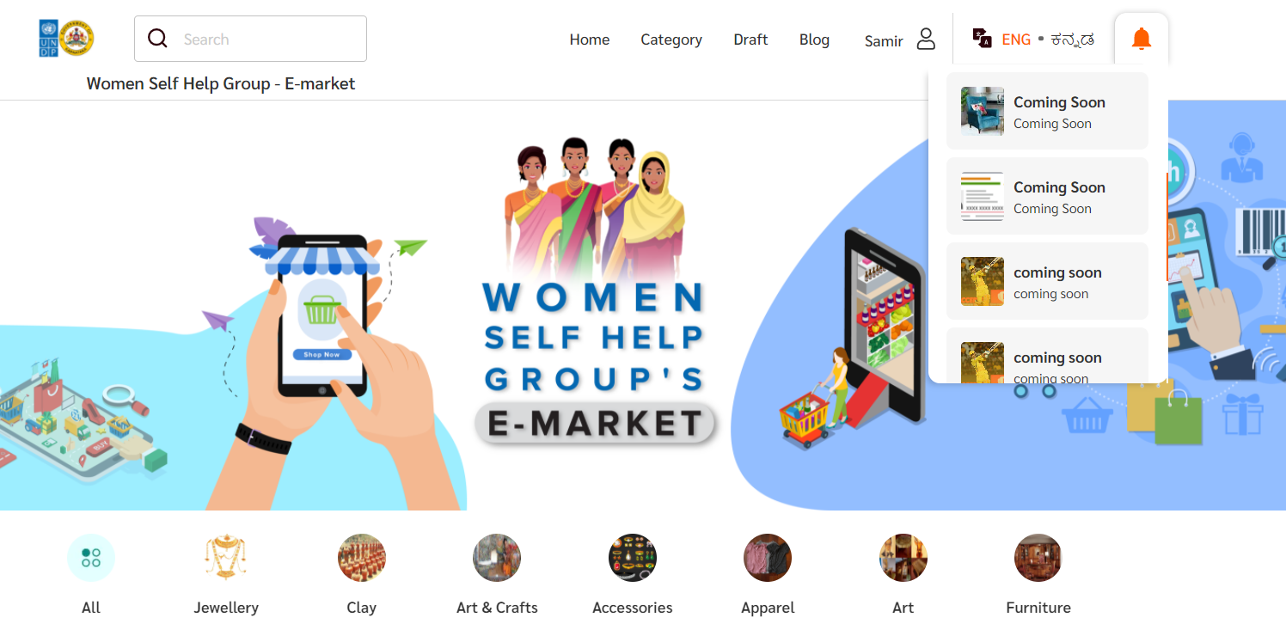Notification will be sent out instantly to selected user group & can be viewed under notification icon in website and in mobile app. 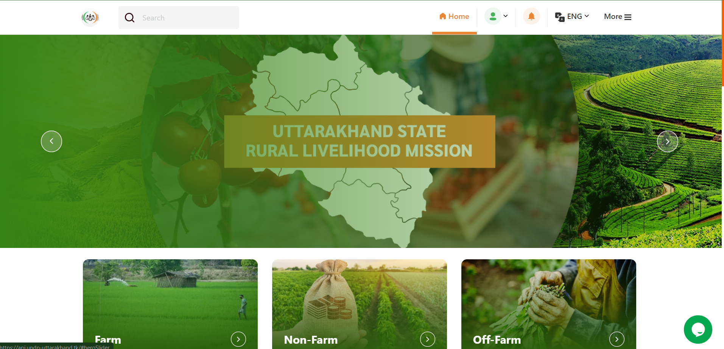

# **Section 5: Order Management**

## Order Management

In this section admin can view & extract orders placed by buyers through Ajeevika web and mobile application which has been accepted by CLFs or SHGs.

Click on “Order Management” button from side panel. Here admin can see the following details of orders placed by users:

1. Order Id
2. Interest Id
3. Date of Sales
4. Date of Creation
5. Mode of Delivery
6. Order Value
7. Order Status
8. Buyer Name
9. Buyer Phone

Admin can also search order details via Order Id & Interest Id through search bar.

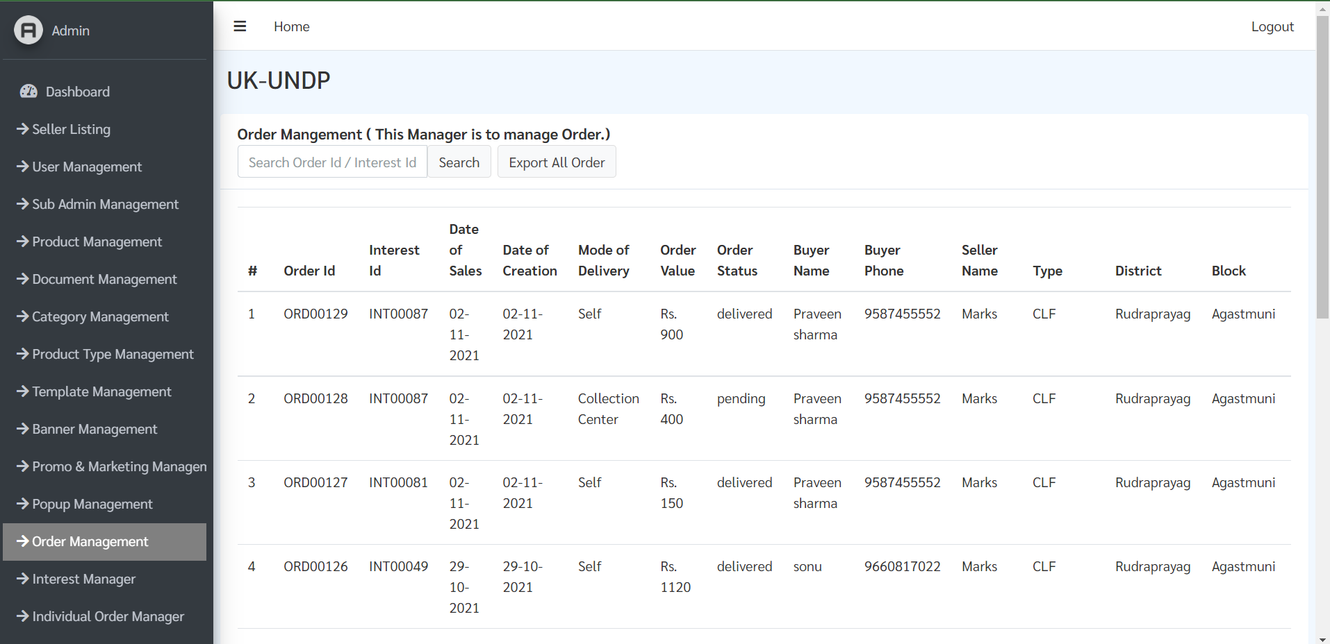

To export all data click on “Export All Order” button highlighted above.

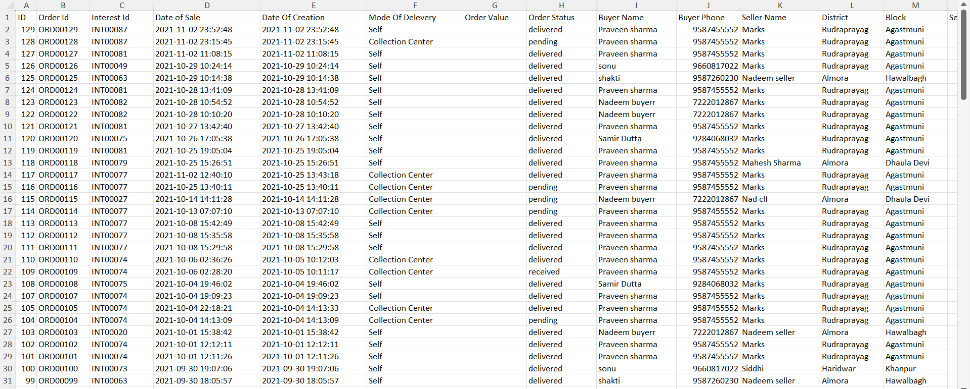

## Interest Management

In this section admin can view & extract details of interest placed by buyers through Ajeevika web and mobile application.

Click on “Interest Manager” button from side panel. Here admin can see the list of interest placed along with following information.

1. Interest Id
2. Date of Creation
3. Buyer Name
4. Buyer Phone
5. Seller Name
6. Type
7. District

Admin can view details of order including product name, price, quantity & message by clicking “View” button against Interest Id.

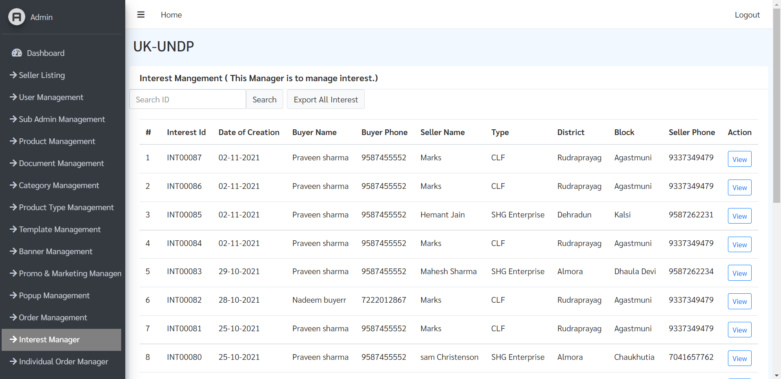

Order Detail

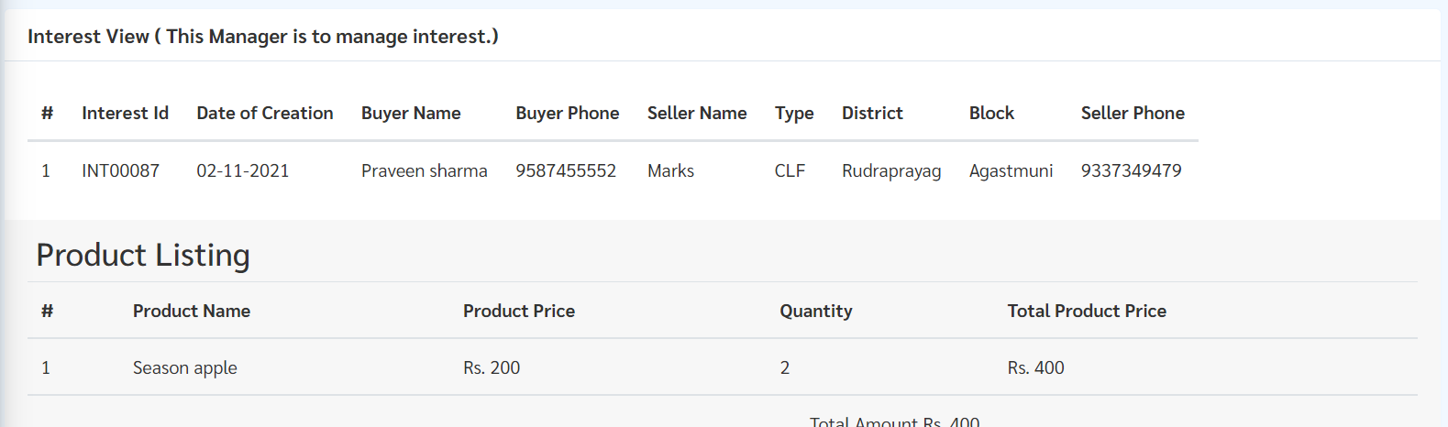

Admin can also search order details via Interest Id through search bar & export all information in excel sheet by clicking “Export All Interest” button highlighted above.

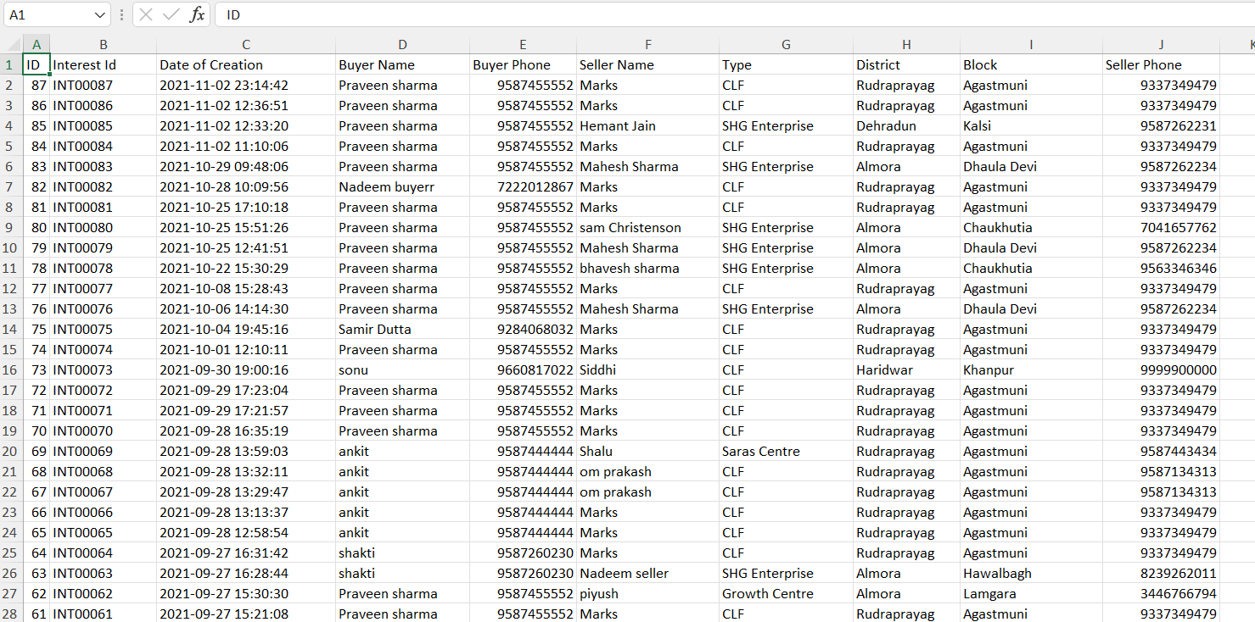

## IndividualOrder Management

In this section admin can view & extract details of order placed by SHG Individuals through Ajeevika web and mobile application.

Click on “Individual Order Manager” button from side panel. Here admin can see the list of interest placed along with following information.

1. Order Id
2. Date of Sale
3. Buyer Creation
4. Order Status
5. Individual Name
6. Individual Phone
7. CLF Name
8. Block
9. CLF Phone

Admin can view details of order including product name & quantity by clicking “View” button against Interest Id.

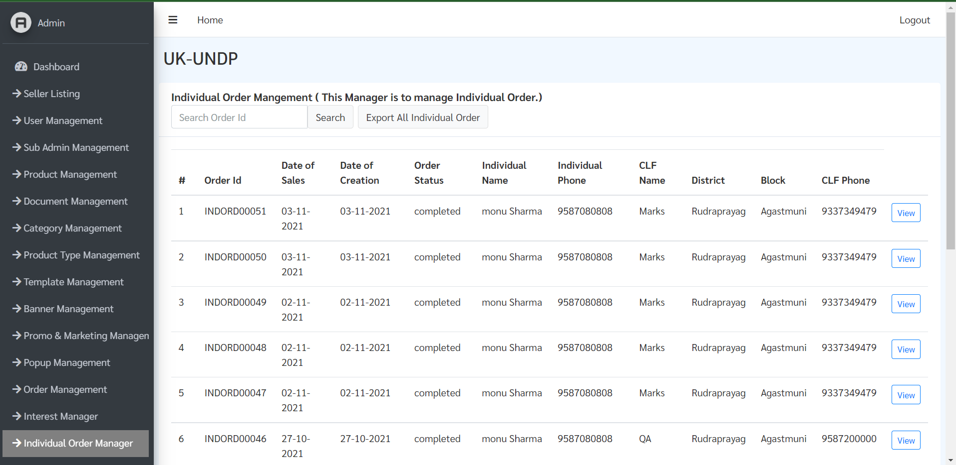

Order Detail

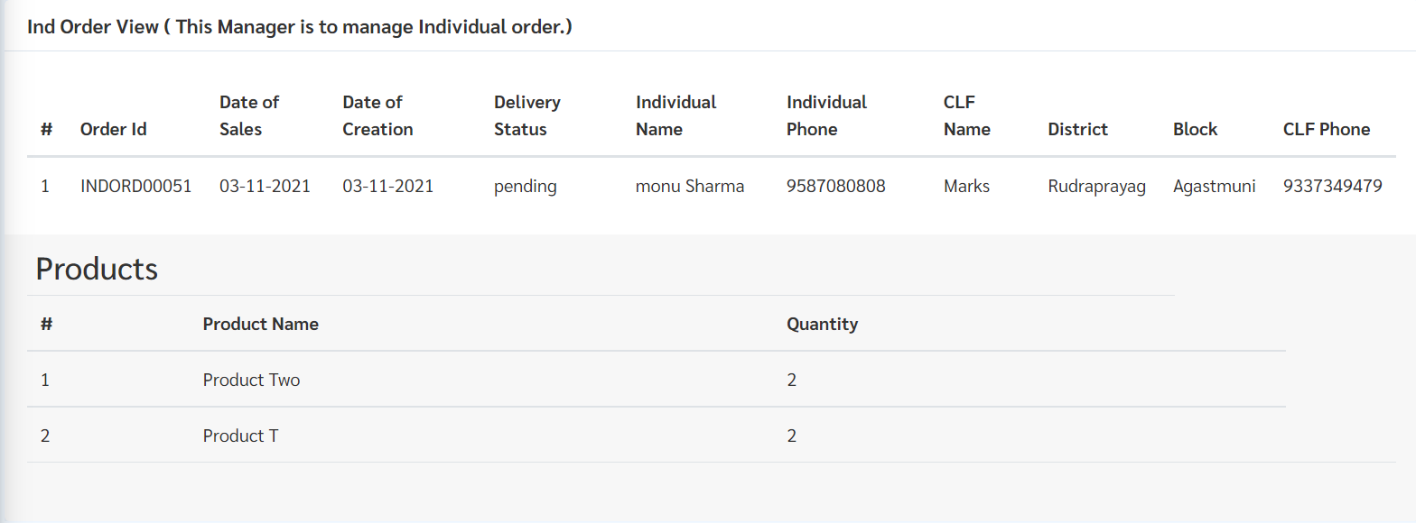

Admin can also search order details via Order Id through search bar & export all information in excel sheet by clicking “Export All Interest” button highlighted above.

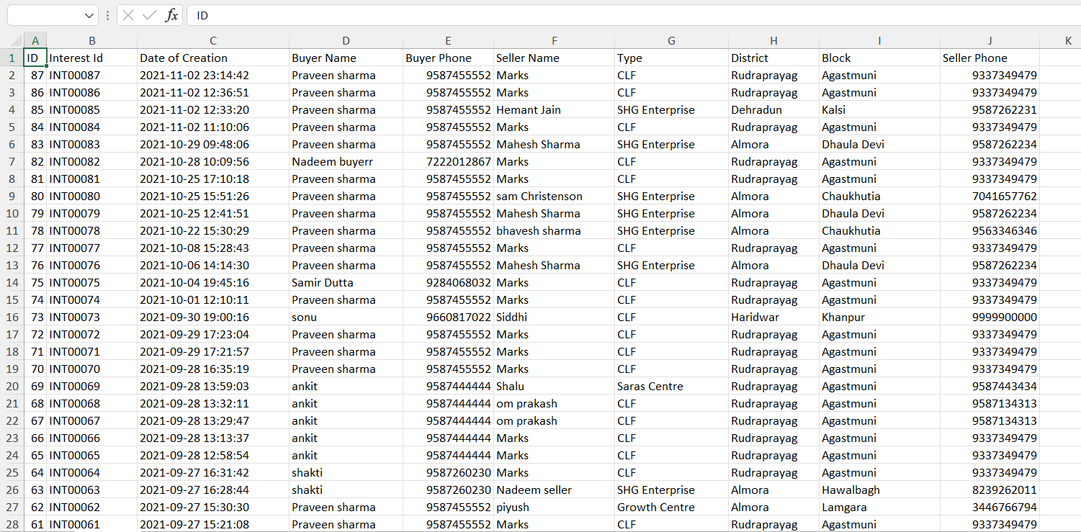

# **Section 6: Other Features**

## Sarvottam Management

In this section admin can view, add new sarvottam, edit & enable /disable existing sarvottam for SHG Individual application.

**View Sarvottam**: To view existing sarvottam click on “PDF” link adjacent to the sarvottam you want to view & the existing sarvottam pdf will download.

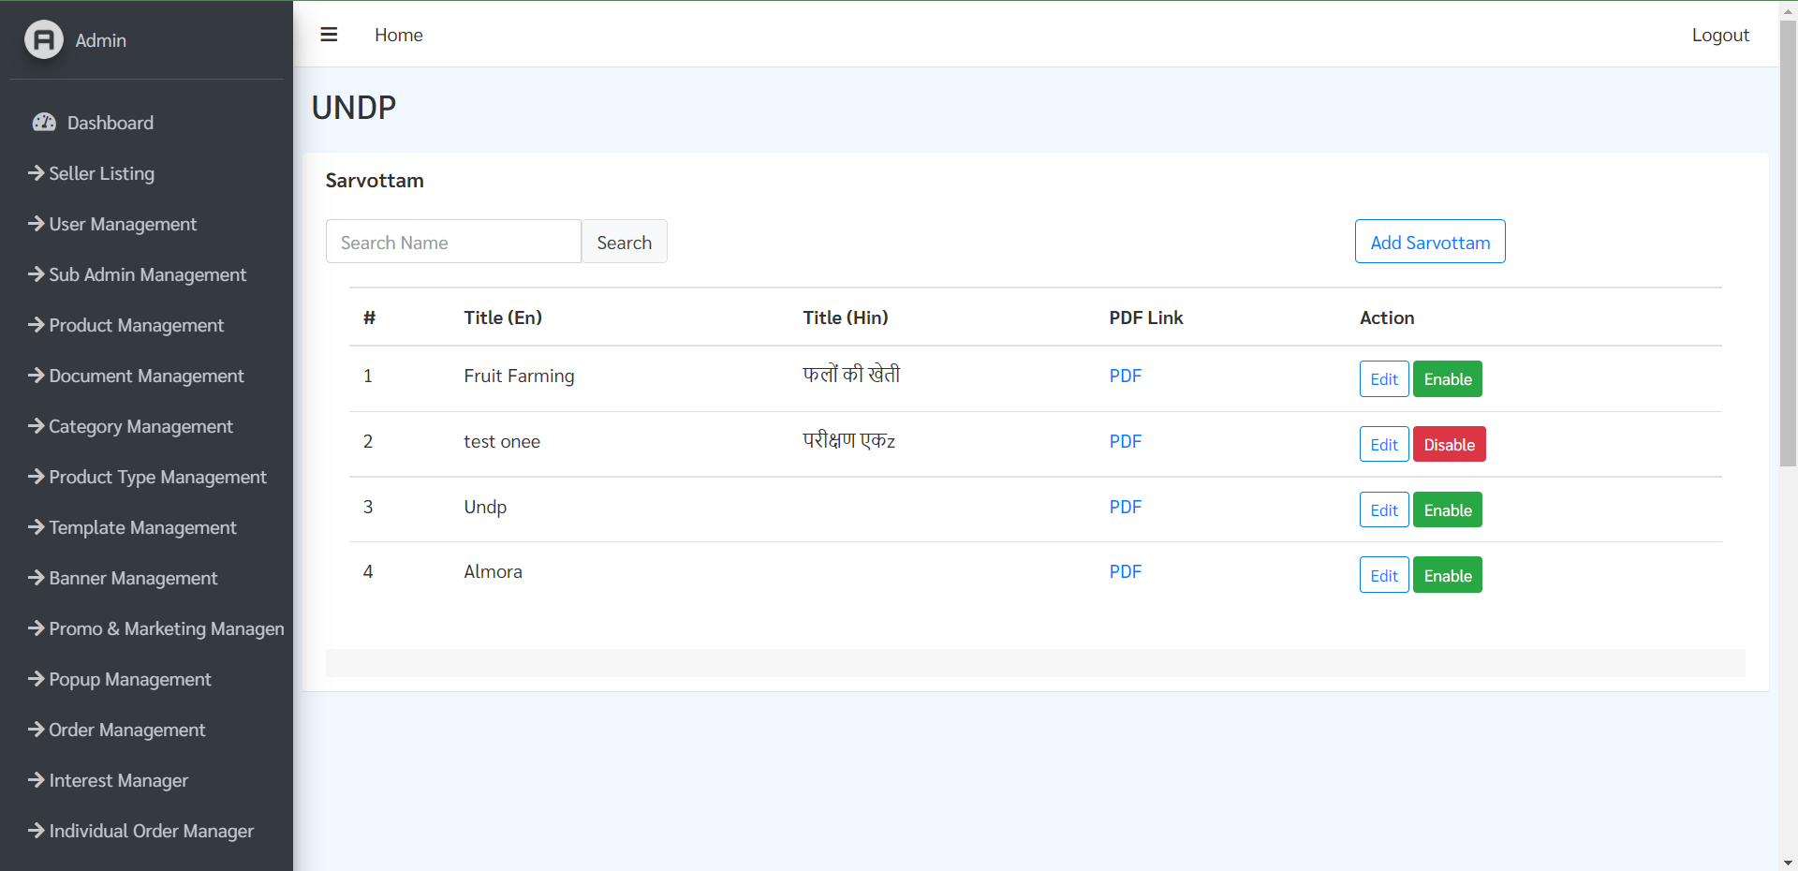

**Edit Sarvottam**: To edit existing sarvottam click on “Edit” button adjacent to the sarvottam you want to edit & the sarvottam edit page will open.

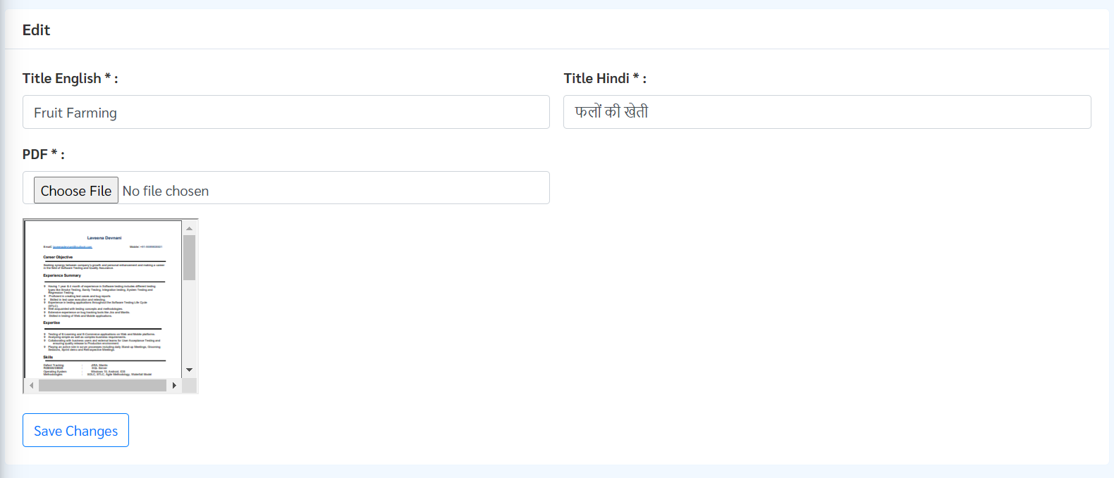

In this page admin can edit title and or PDF and after making necessary changes click on” Save Changes” button to update sarvottam.

**Add New Sarvottam**:

Step1: To create new sarvottam, click on “Add Sarvottam” button highlighted below.



Step 2: On the next page add Title for sarvottam in English and Hindi and upload PDF for sarvottam and click on “Add” button.

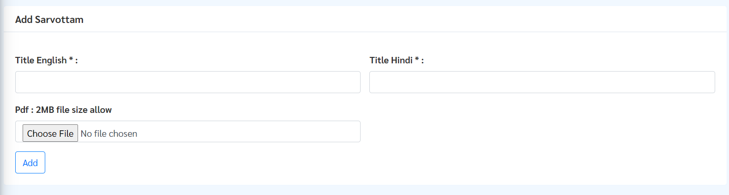

**Enable/Disable Sarvottam**: To view enable/disable sarvottam click on “Enable/Disable” button adjacent to the sarvottam you want to enable or disable.



## Sadhan Management

In this section admin can view, add new sadhan, edit & enable /disable existing sadhan for SHG Individual application.

**View Sadhan**: To view existing sadhan click on “Sadhan Management” button from side panel. Here list of existing sadhan along with Title, Category & Description is present.

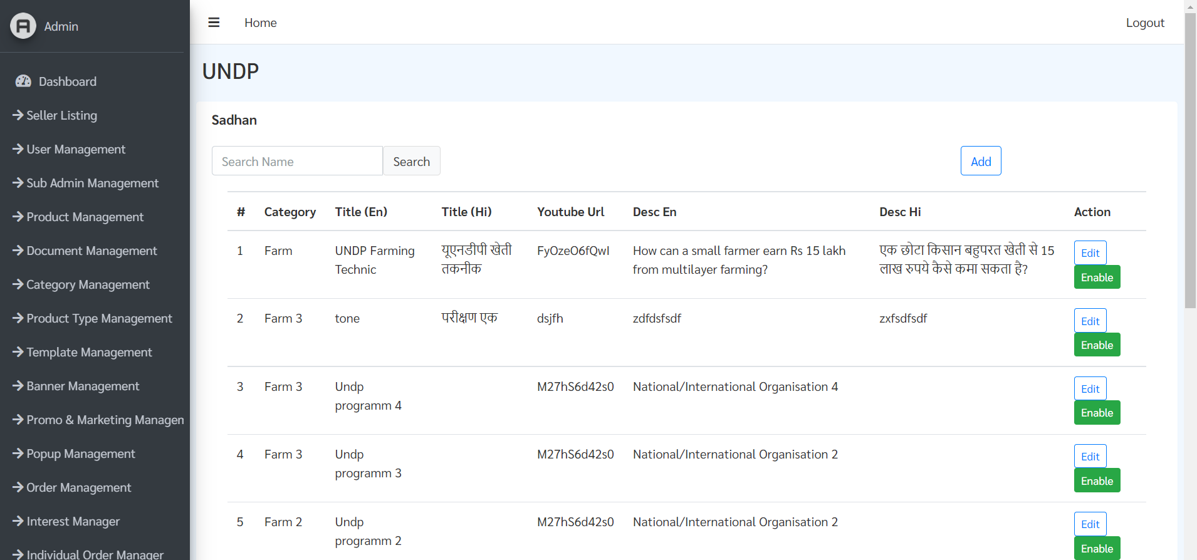

**Edit Sadhan**: To edit existing sadhan click on “Edit” button adjacent to the sadhan you want to edit & the sadhan editing page will open.

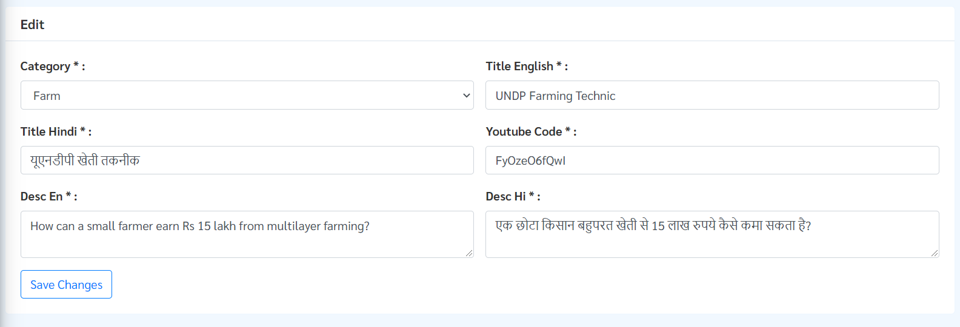

In this page admin can edit details of sadhan including:

1. Category
2. Title (Both English & Hindi)
3. YouTube link
4. Description (Both English & Hindi)

After making necessary changes click on “ Save Changes” button to update sadhan.

**Add New Sadhan**:

Step1: To create new sadhan, click on “Add Sadhan” button highlighted below.

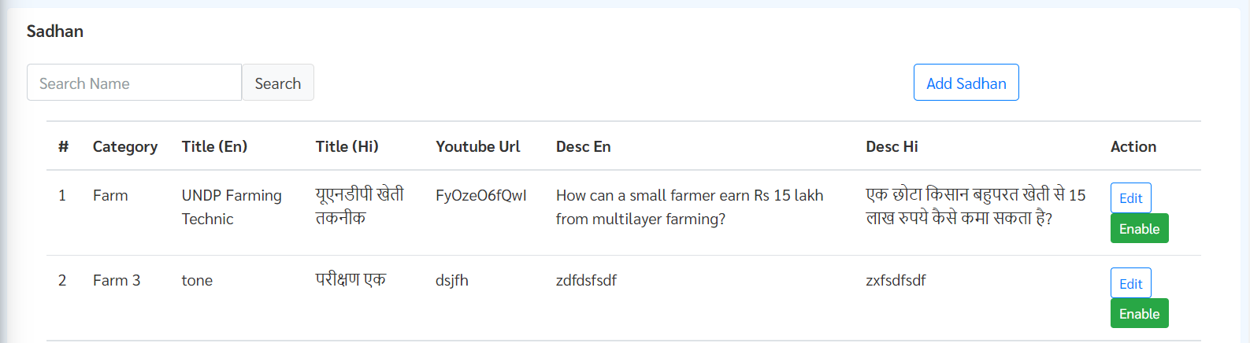

Step 2: On the next page select Category, add Title (in both English & Hindi), add Youtube code* and last add Description (in both English & Hindi) click on “Add” button to create new sadhan.

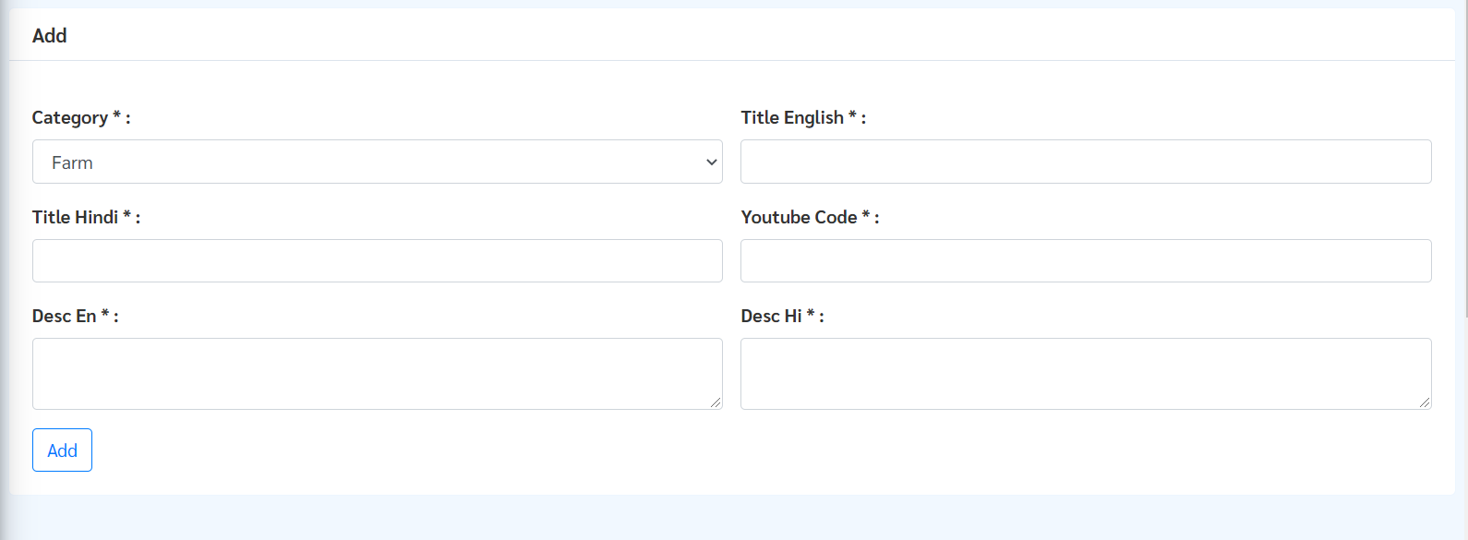

**Enable/Disable Sadhan**: To view enable/disable sadhan click on “Enable” button adjacent to the sadhan you want to enable/disable



## Suvidha Management

In this section admin can view, add new suvidha, edit & enable /disable existing suvidha for SHG Individual application.

**View Suvidha**: To view existing sadhan click on “Suvidha Management” button from side panel. Here list of existing sadhan along with Title, Category & Description is present.

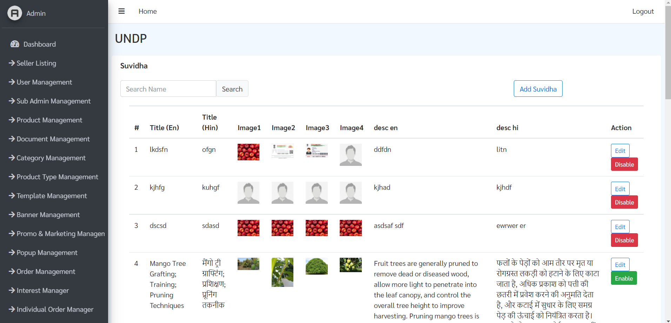

**Edit Suvidha**: To edit existing sadhan click on “Edit” button adjacent to the sadhan you want to edit & the suvidha editing page will open.

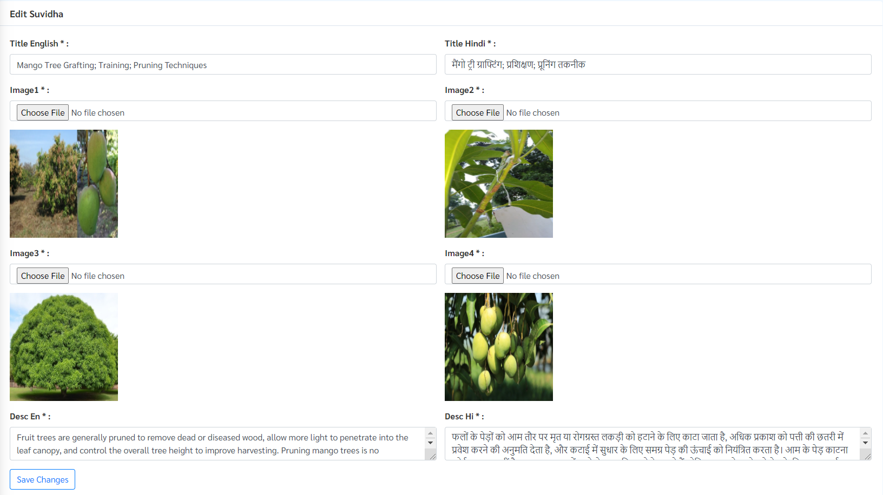

In this page admin can edit details of suvidha including:

1. Title (Both English & Hindi)
2. Images
3. Description (Both English & Hindi)

After making necessary changes click on “Save Changes” button to update sadhan.

**Add New Suvidha**:

Step1: To create new suvidha, click on “Add Suvidha” button highlighted below.



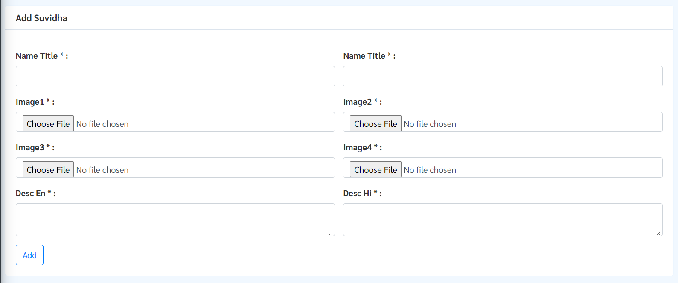

Step 2: On the next page add Title (in both English & Hindi), add display images(3) and last add Description (in both English & Hindi) & click on “Add” button to create new suvidha.



**Enable/Disable Suvidha**: To view enable/disable sadhan click on “Enable” button adjacent to the sadhan you want to enable/disable

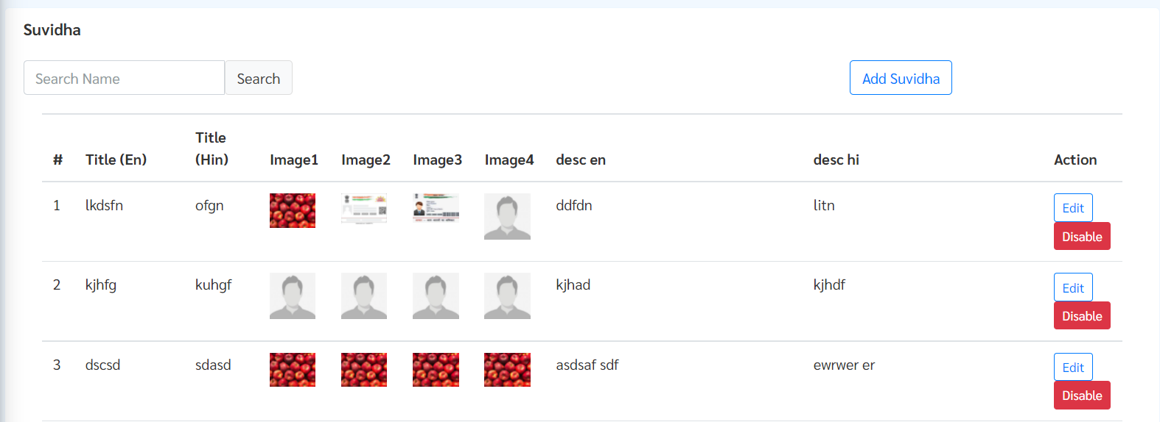

# **Section 7: Support &** **Grievance Addressal**

## FAQ Management

In this section admin can manage FAQs for the entire Ajeevika portal including all users for mobile apps.

**View FAQs**: To view existing sadhan click on “Suvidha Management” button from side panel. Here list of existing sadhan along with Title, Category & Description is present.

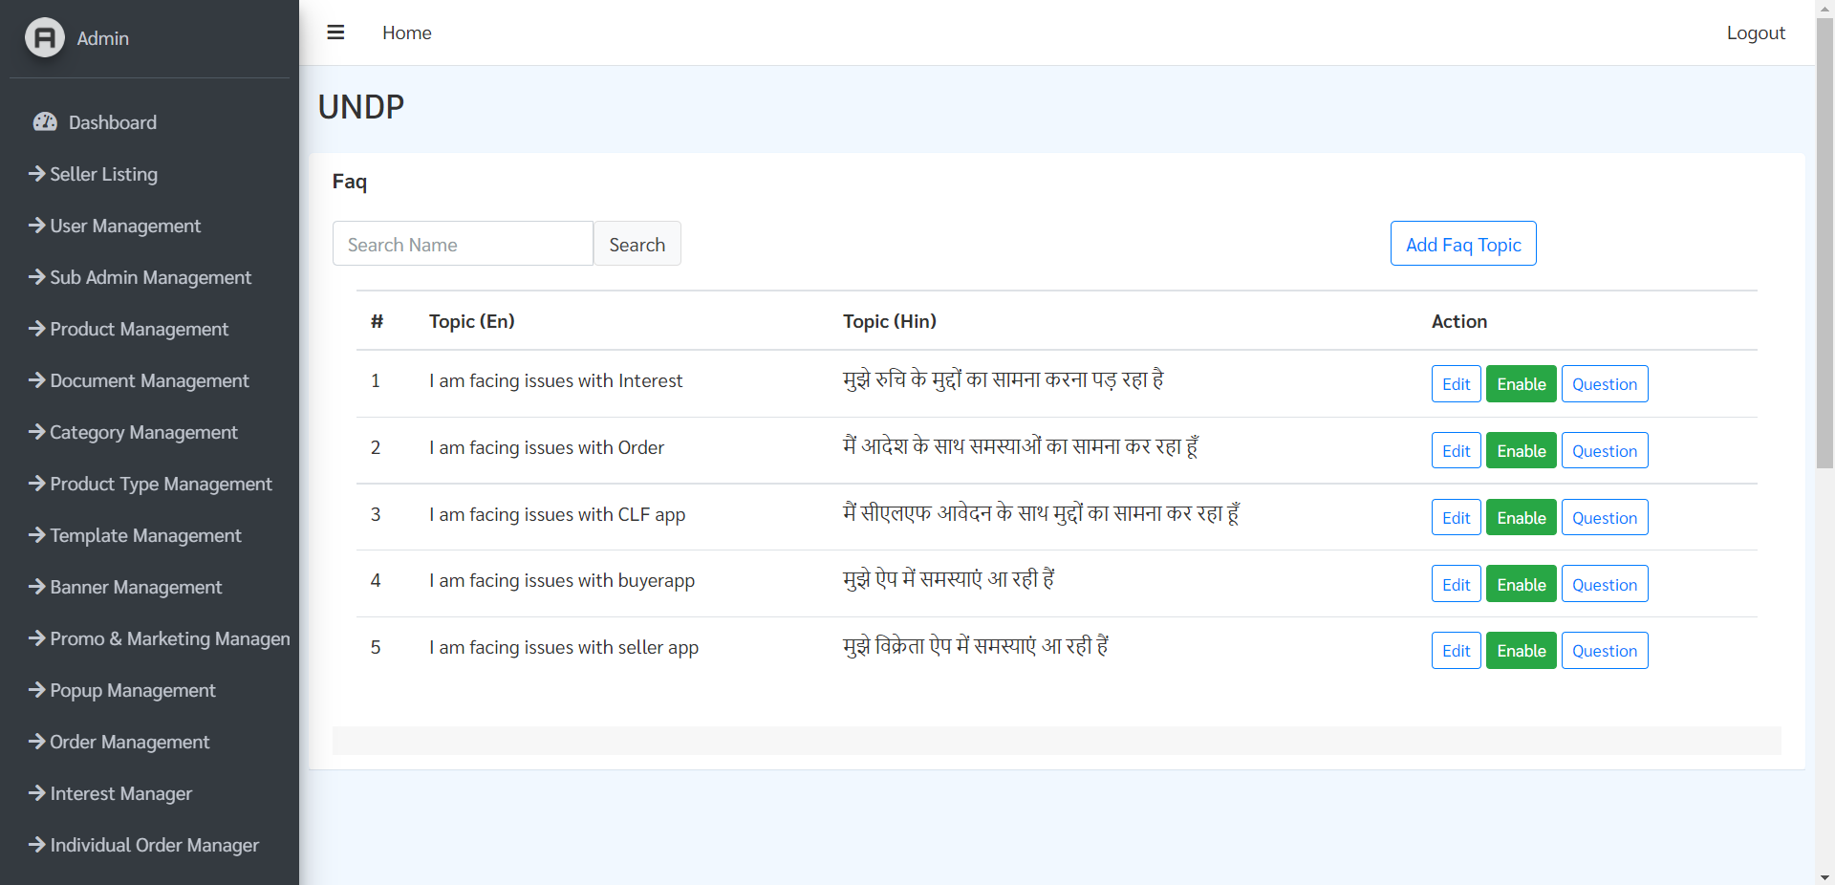

**Edit FAQs**: To edit existing FAQs click on “Edit” button adjacent to the FAQ you want to edit & the FAQ editing page will open.



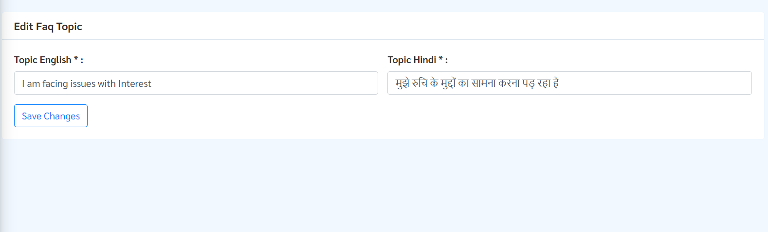

Here admin can edit FAQ Topic in Hindi and in English and after making necessary changes click on “Save Changes”

**Add FAQs**: To view existing sadhan click on “Suvidha Management” button from side panel. Here list of existing sadhan along with Title, Category & Description is present.

**Enable/Disable FAQs**: To view existing sadhan click on “Suvidha Management” button from side panel. Here list of existing sadhan along with Title, Category & Description is present.

## Grievance Management

In this section admin can view and monitor and address grievances for the entire ajeevika portal.

**View Grievance**: To view list of existing grievances in the portal click on “Grievance Management” button from side panel.

Here list of existing grievances along with following details

1. User Name
2. Type, Mobile
3. Issue Type
4. Ticket ID
5. Status
6. Action

Admin can search through any grievances by their respective ticket IT through search bar.

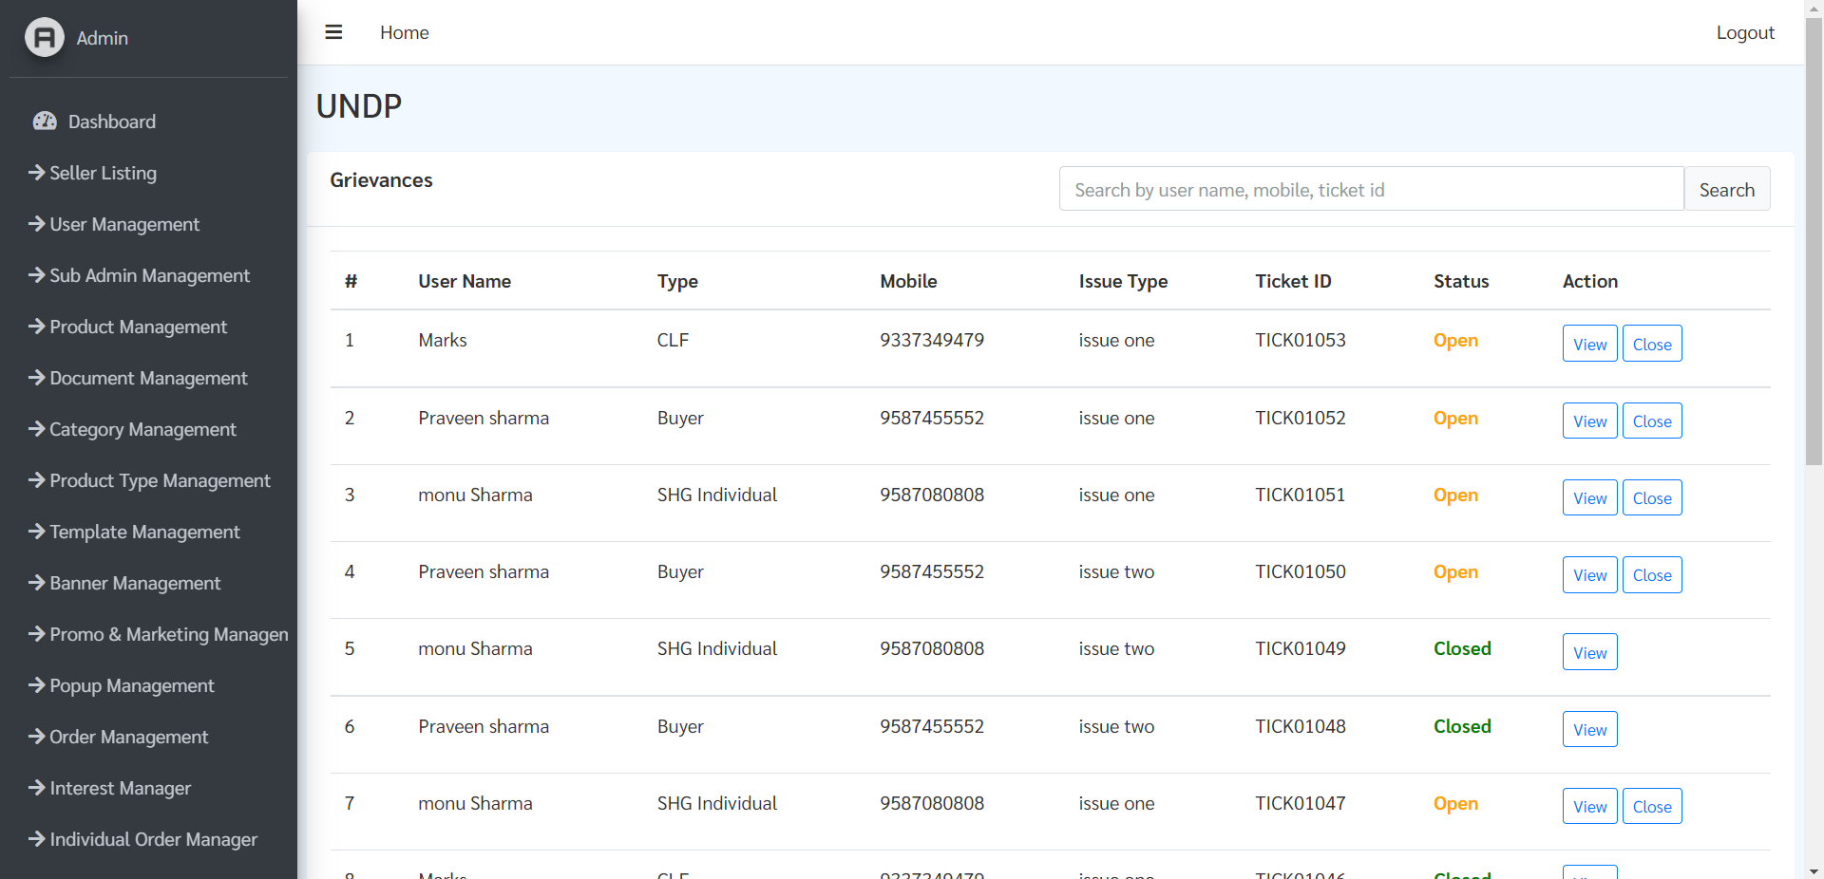

**Grievance Management**: Follow the steps to manage grievance:

Step 1: To manage grievance click on “View” button adjacent to grievance you want to manage

Step 2: On this page admin can chat with issue raiser to manage his/her issue.

Step 3: Once issue is resolved then admin can click on “Close” button highlighted below.

